SERVICING MODULE Murabaha Restructuring
Unit Test Document Version 1.1
MARCH 30, 2026

Document History
Author | Version | Date | Description
Muhammad Ali  Muhammad Asad | V1.0 | 17th MAR 2026 | Initial Document
Muhammad Asad | V1.1 | 30th MAR 2026 | Old arrangement early payoff amount through API screenshots updated

Contents
Old Arrangement Details 4
OLD Arrangement Early payoff amount 4
New / Restructure Arrangement Creation 6
New Application Details 6
New application creation 6
Qarar Response 7
Presales Queue 8
New Application Overview 8
Transact Simulation 9
Financial Details 9
Simah Details 10
Servicing Module 10
Application Approval 11
Offer Generation 13
Offer Acceptance 14
Application Details in Transact 15
STP Process 15
Bill Generation 16
Bill Payment 17
Contract 18
Promissory Note 20
STP Complete 22
New Arrangement 22
New Arrangement Accounting Entries 23
New Arrangement’s Repayment Account 23
Disbursement 24
Payoff of Old Arrangement 26

Old Arrangement Details
Application ID: 6LYQ4F5
Contract amount: 25,000.00
Contract Tenor: 6 Months
Contract No / AA REF : AA25337H0LYS
Old Maturity Date: 20260528

OLD Arrangement Early payoff amount
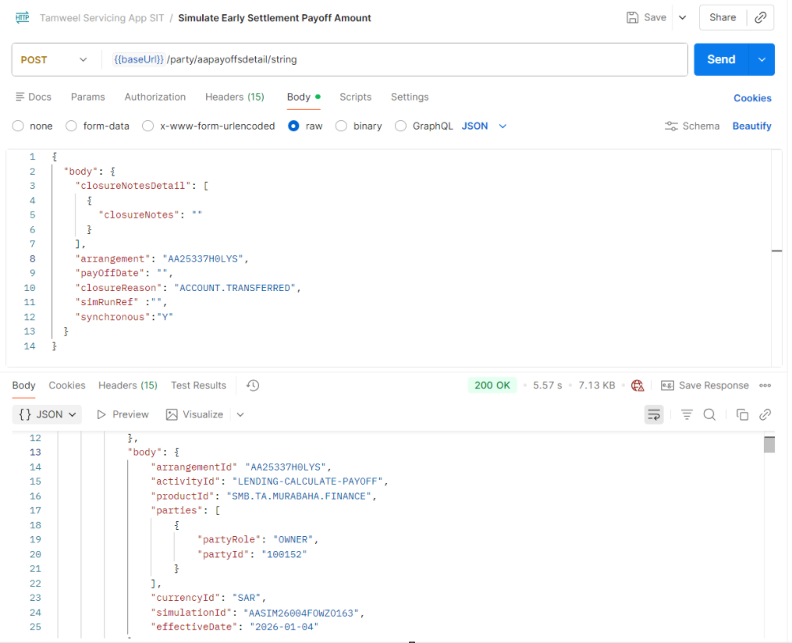
Early payoff simulation of old arrangement
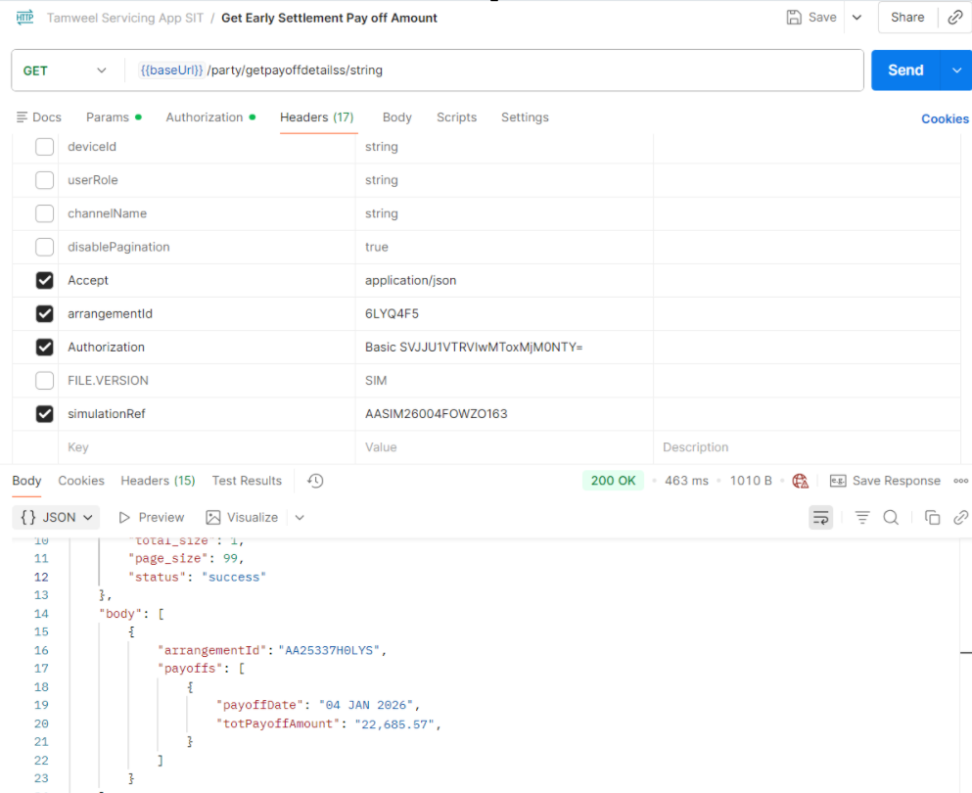
Early payoff amount of old arrangement

New / Restructure Arrangement Creation

New Application Details
Application ID: YSMWM54
Contract amount: 22,685.57
Contract Tenor: 12 Months

New application creation
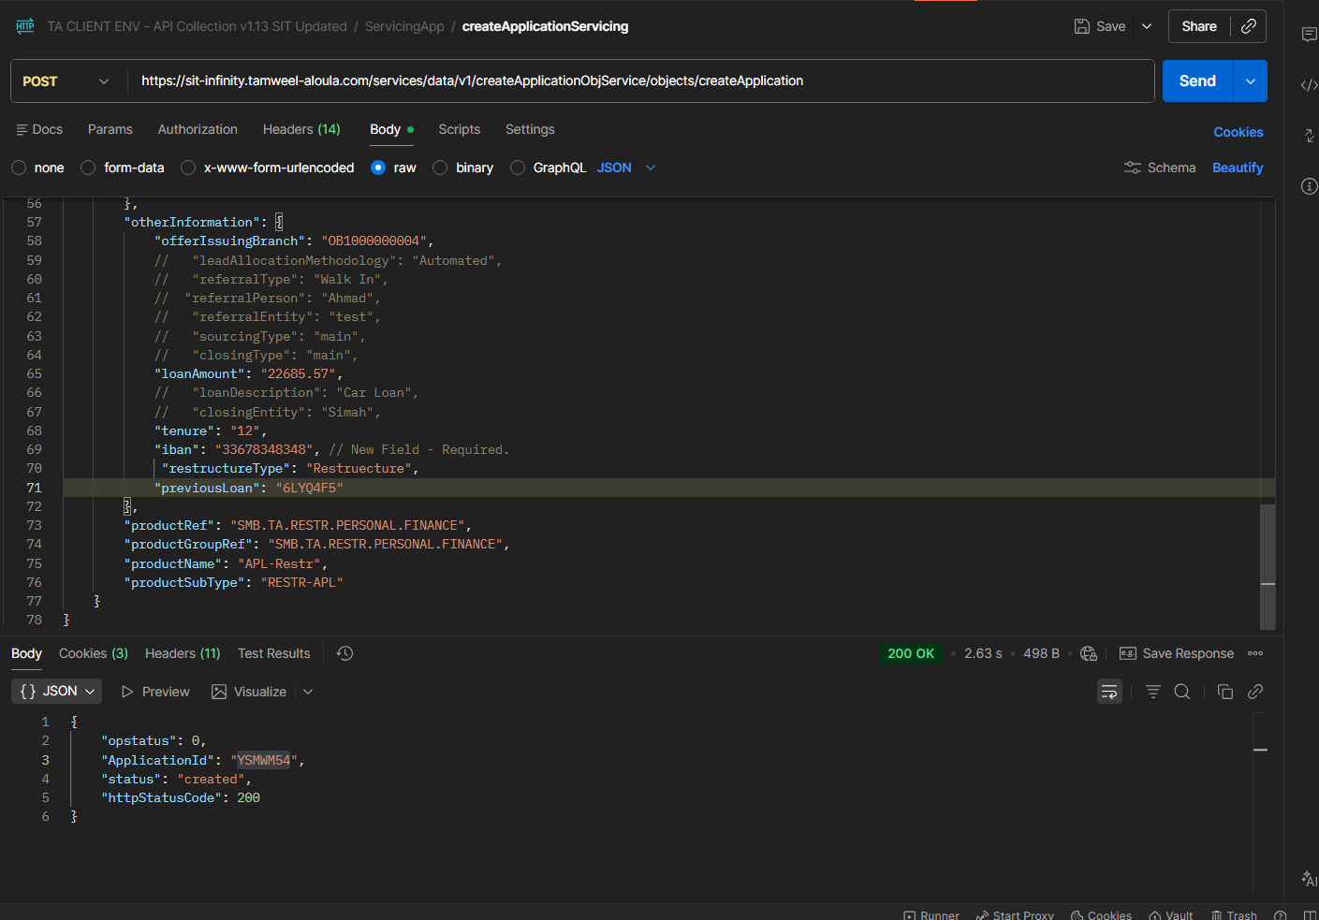

Application created through API
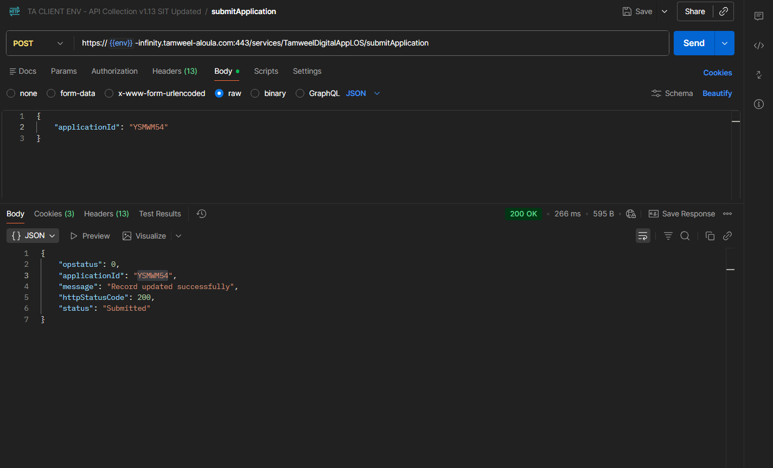
Application submitted through API

Qarar Response
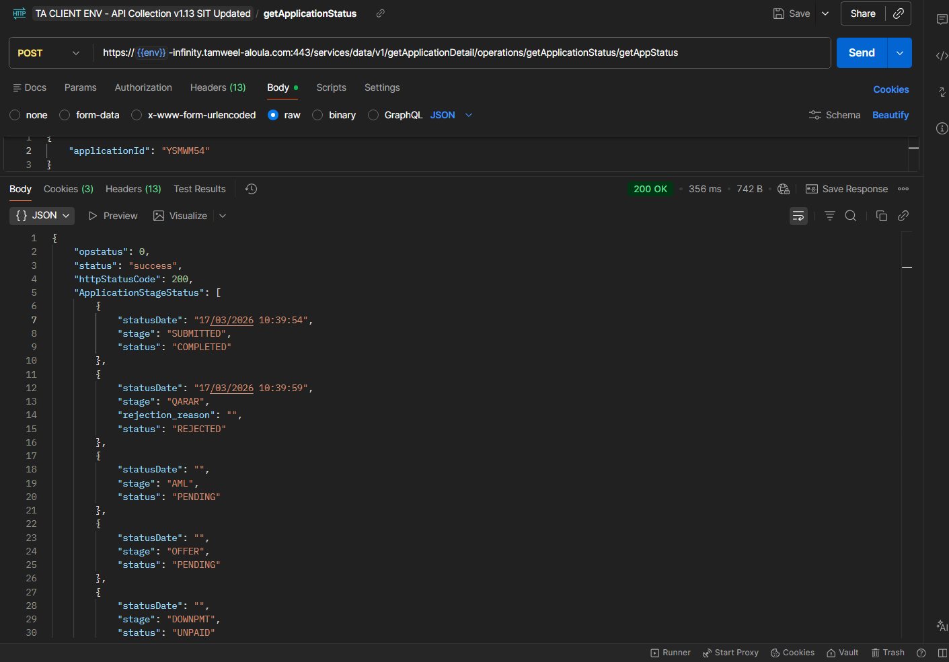
Qarar Response received as Rejected

Presales Queue
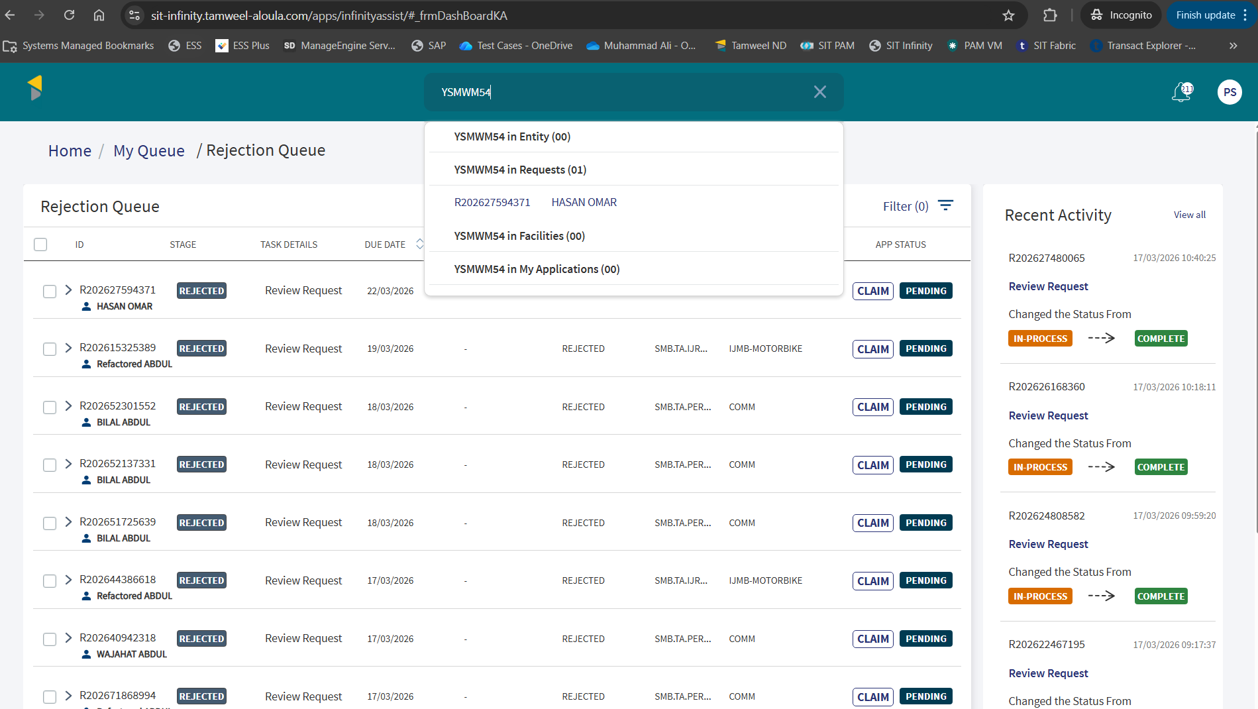
Application is available on assist in presales queue to claim

New Application Overview
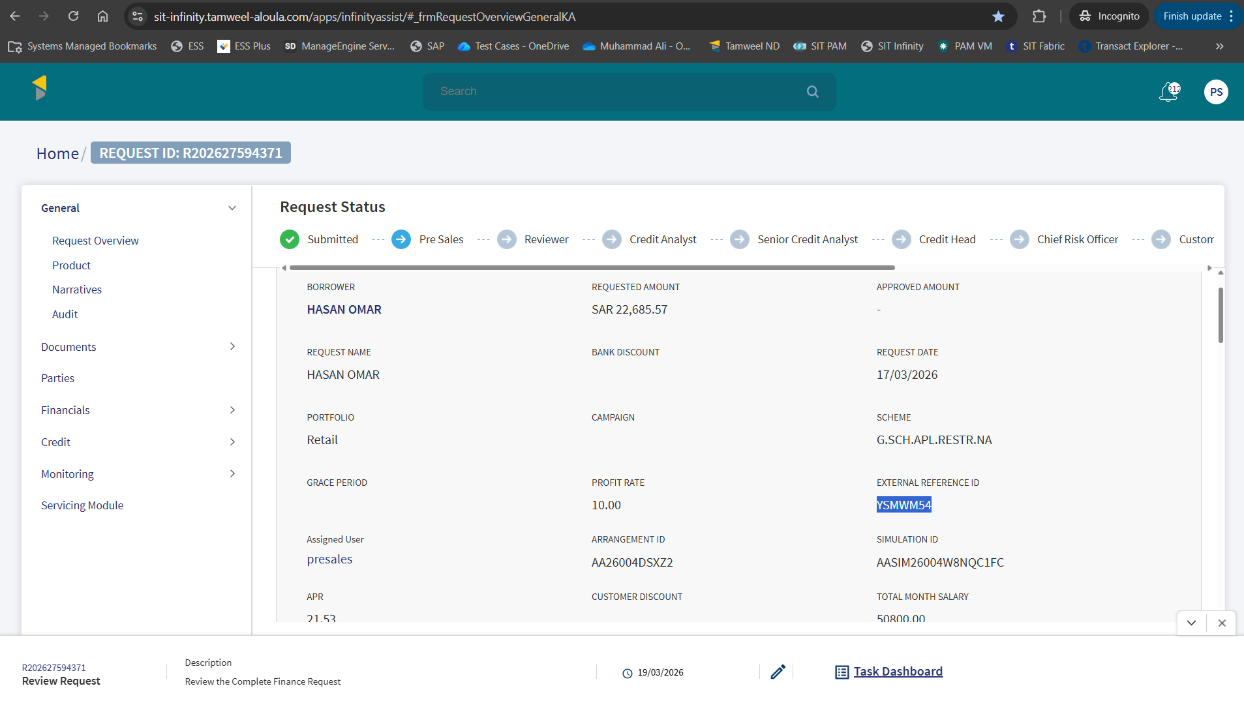
Request Overview details

Transact Simulation
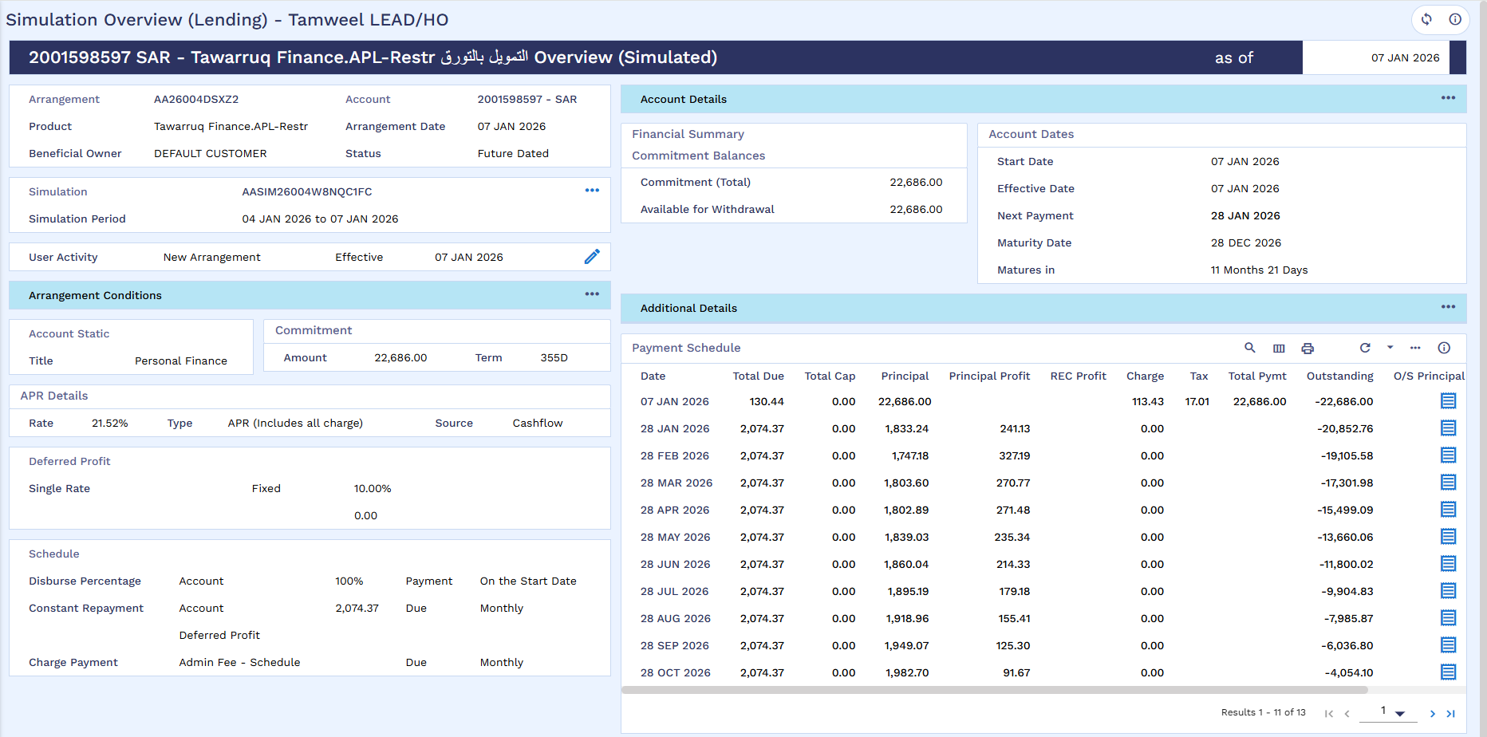
Simulation Created in Transact

Financial Details
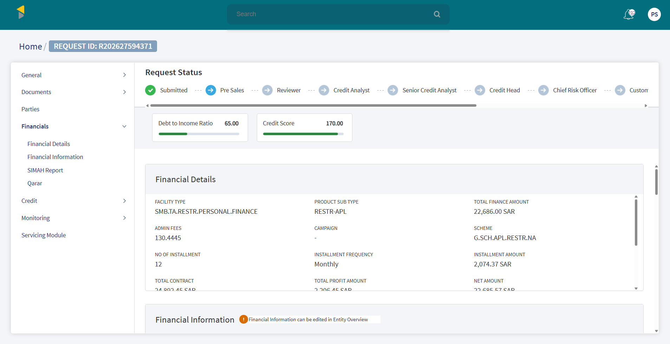
Financial details

Simah Details
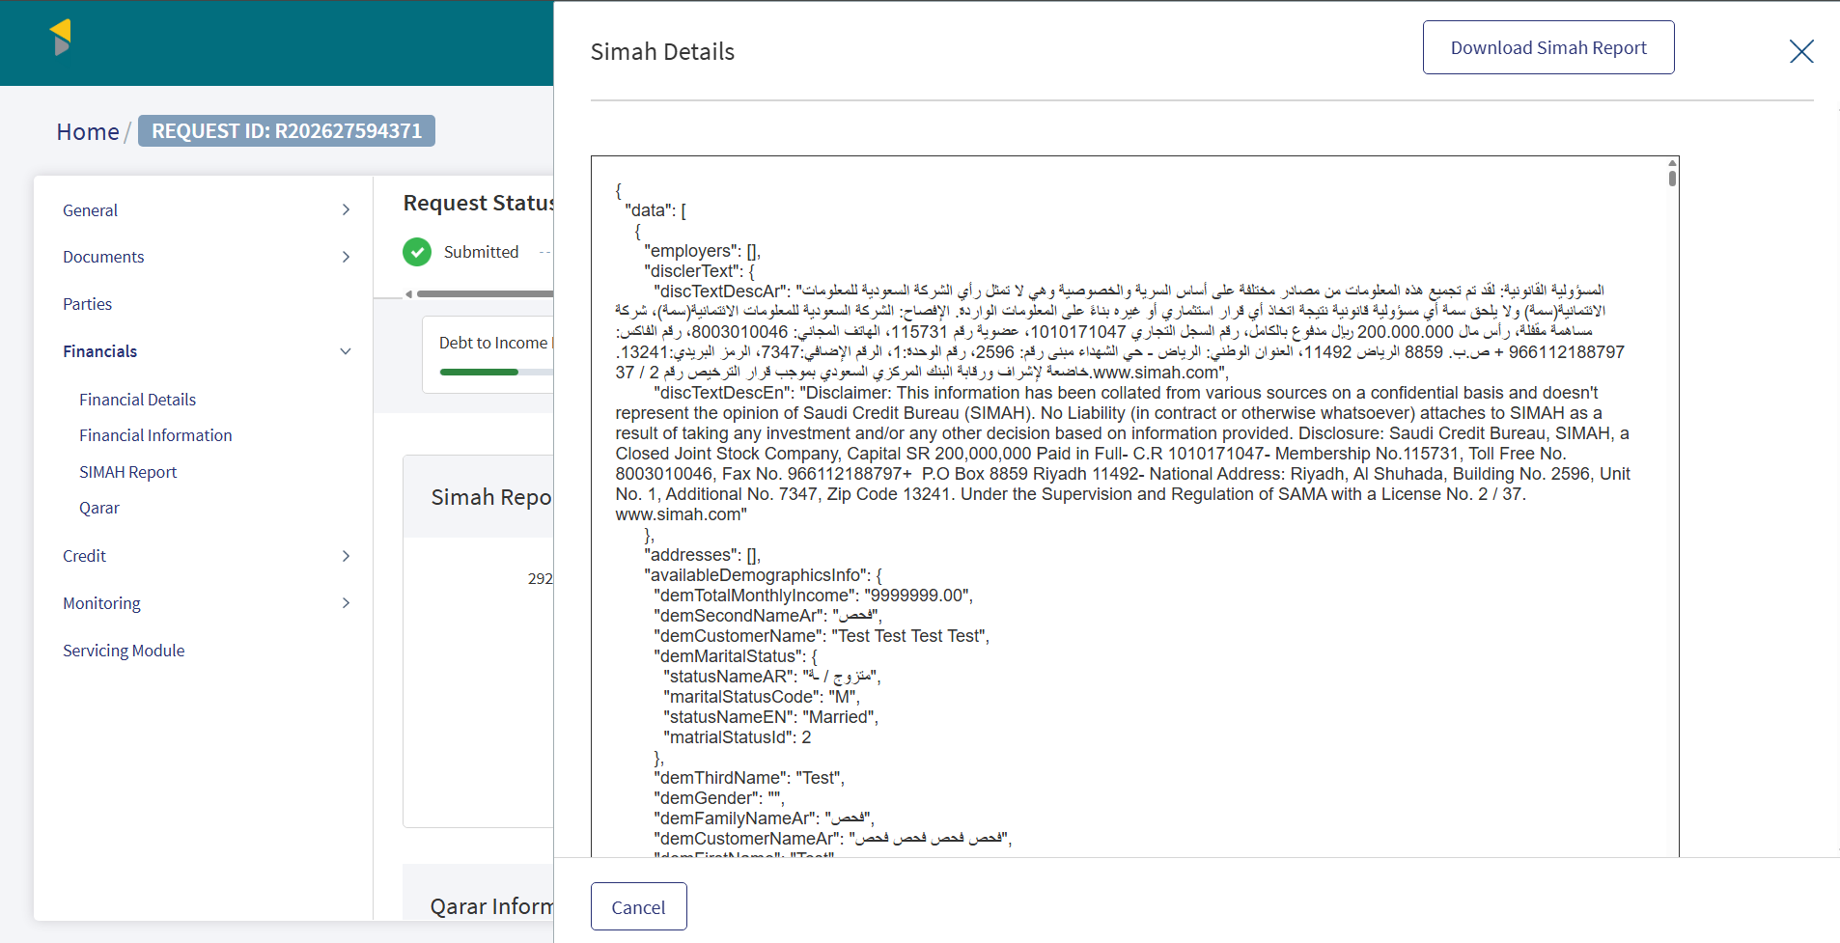
SIMAH Enquiry

Servicing Module
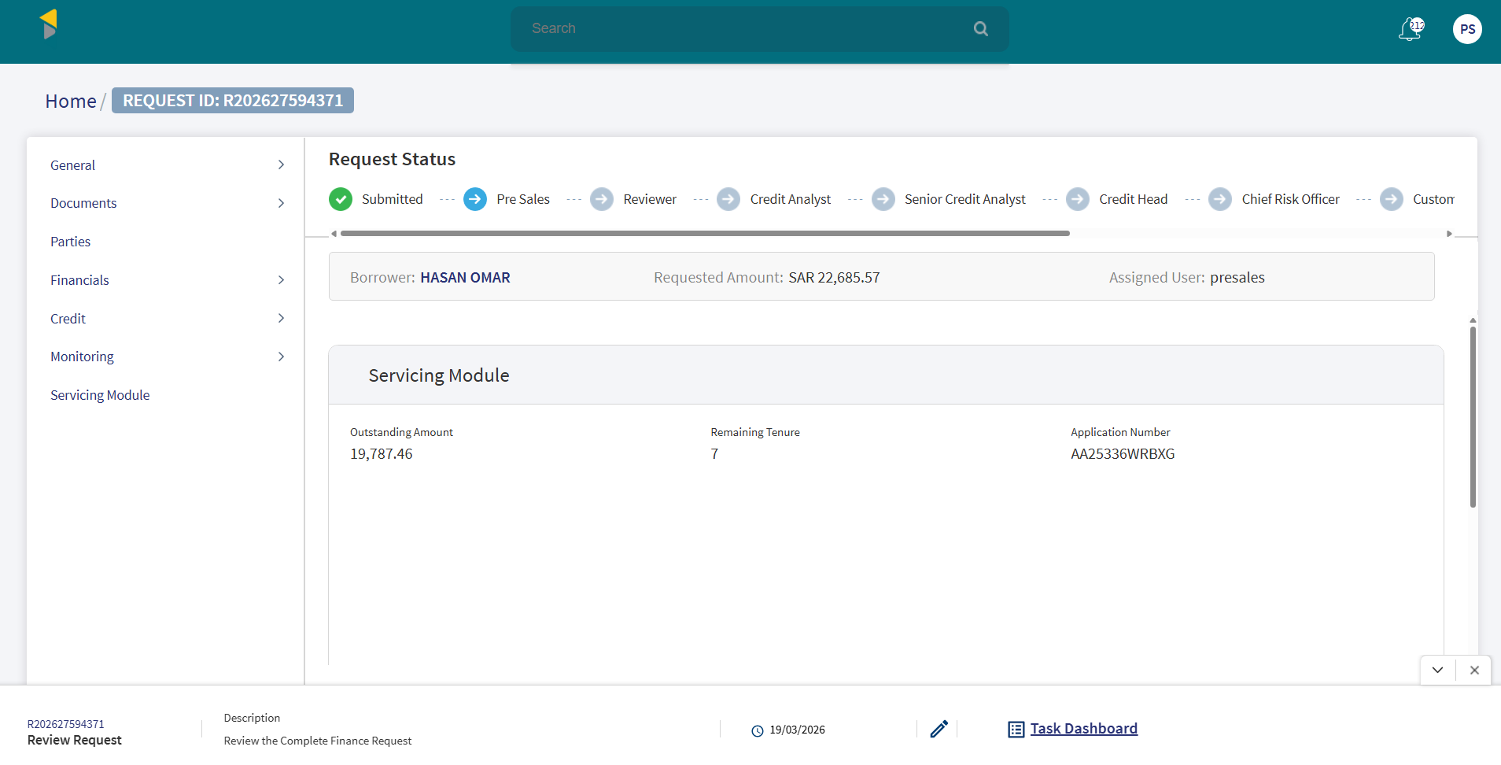
Servicing module section details

Application Approval
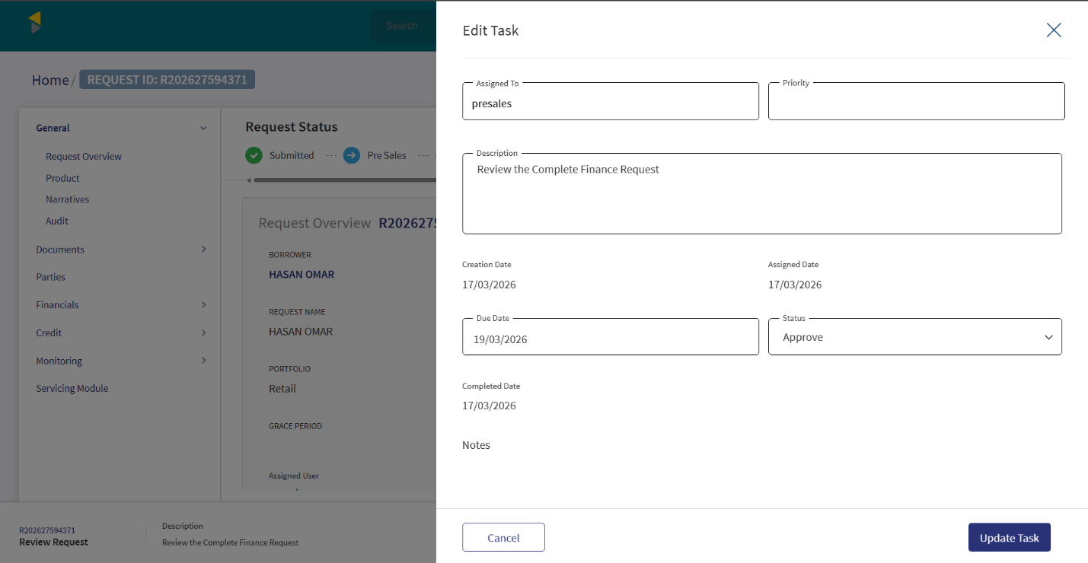
Application approved from Presales
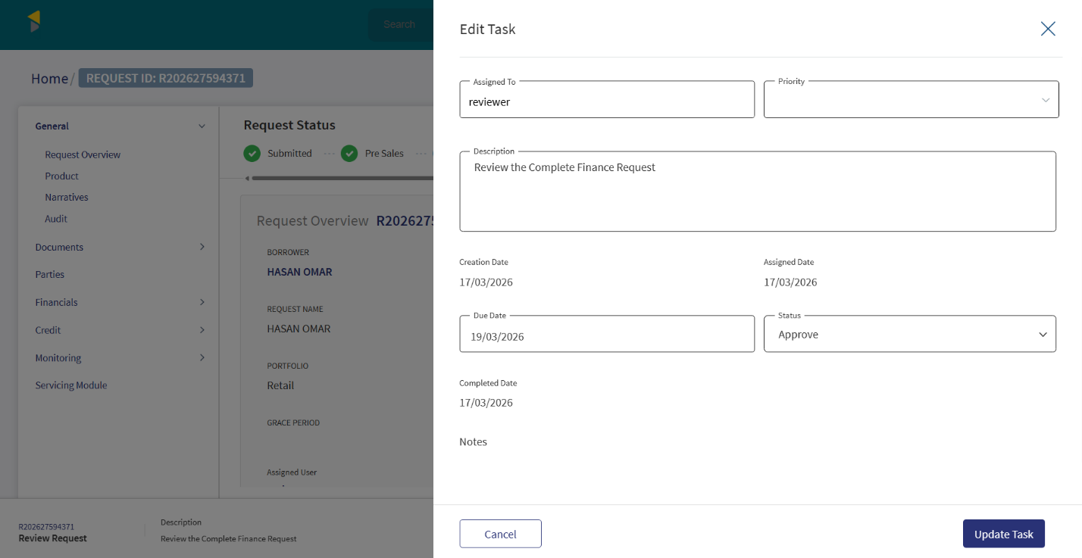
Application approved from Reviewer
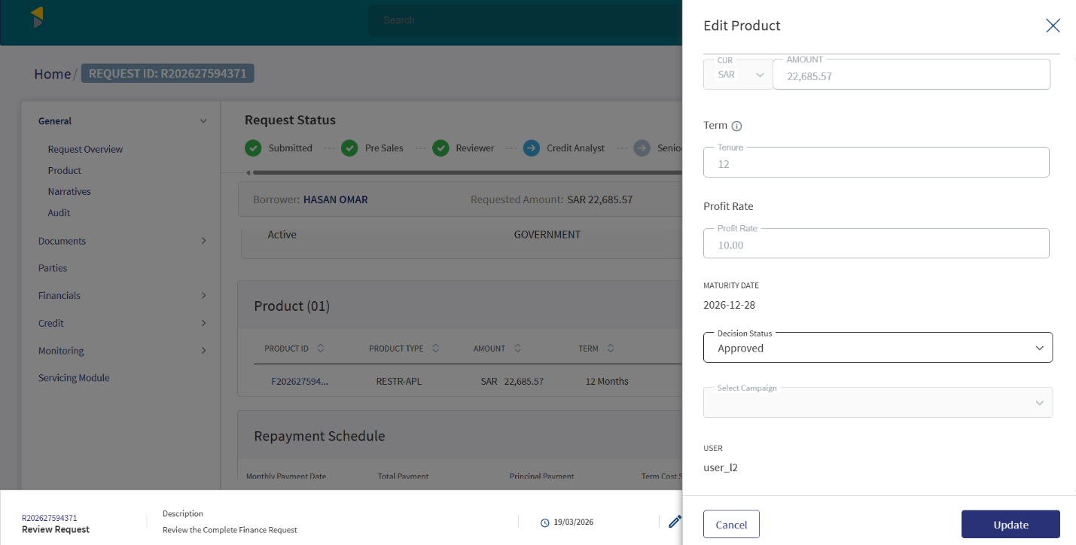
Loan amount approved from Credit Analyst
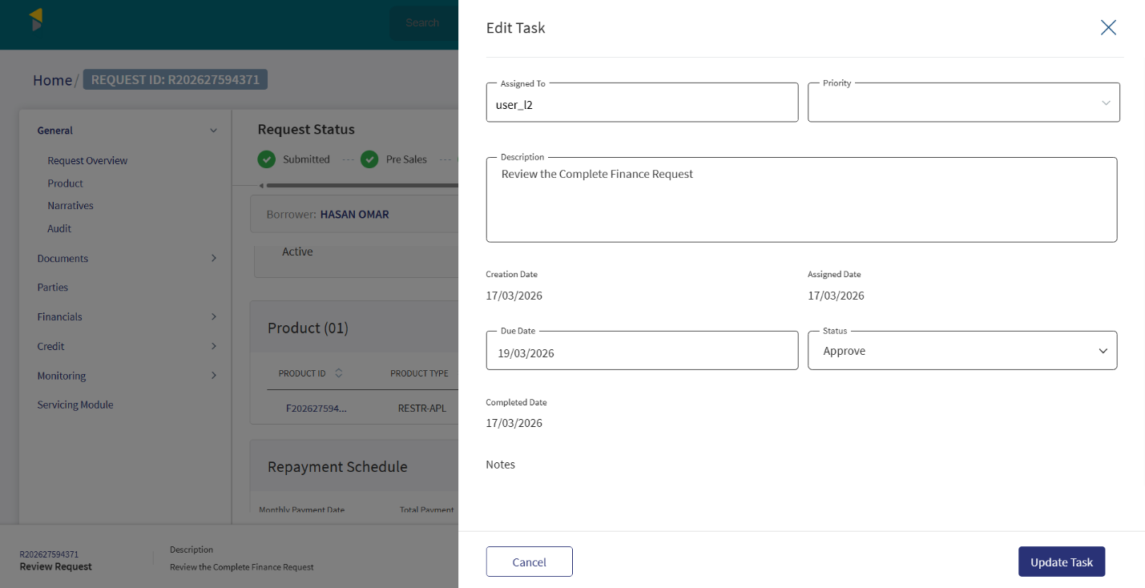
Application approved from Credit Analyst

Offer Generation
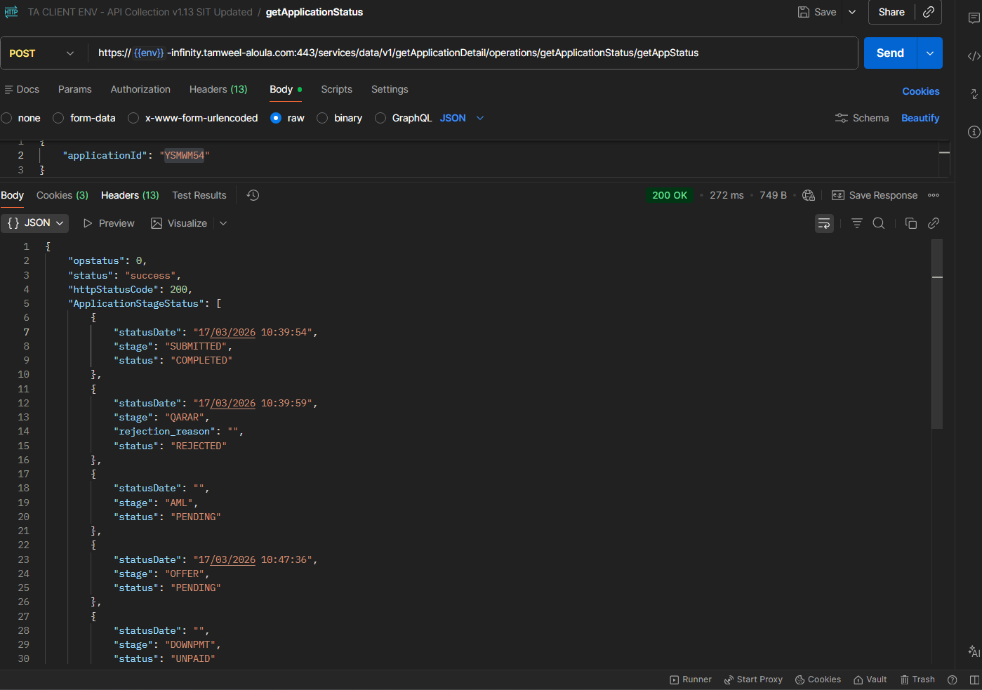
Offer generated

Offer Acceptance
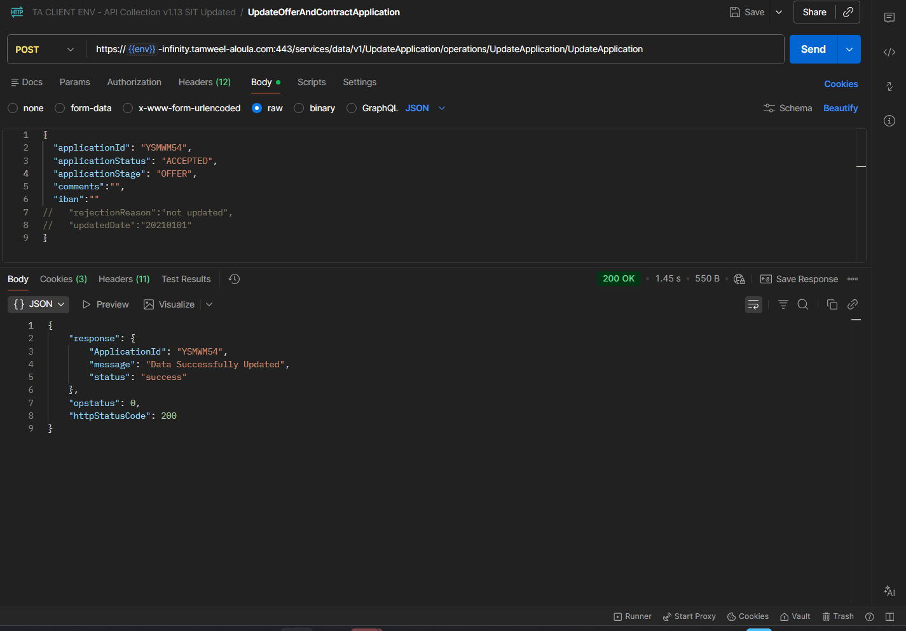
Offer accepted through API

Application Details in Transact
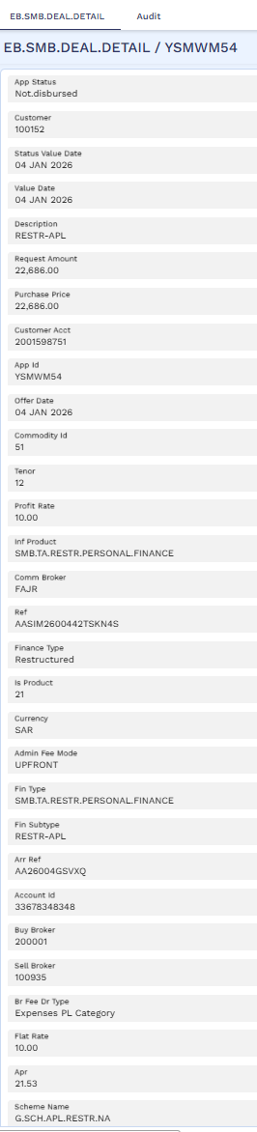
Application Landed on Transact

STP Process
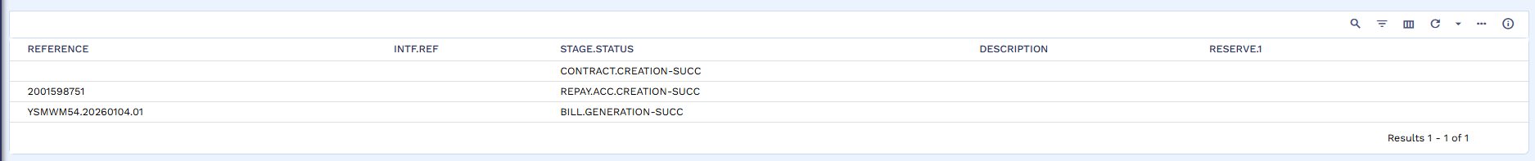
STP process started

Bill Generation
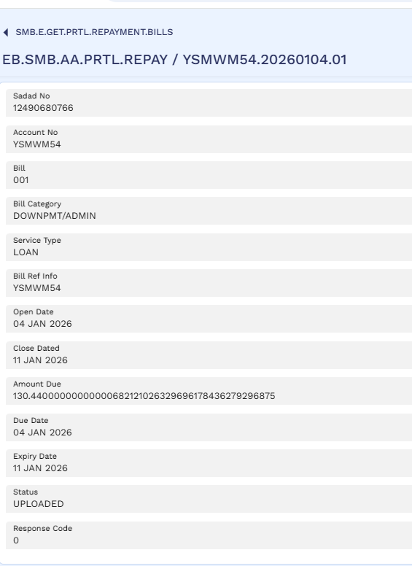
Admin fee bill generated

Bill Payment
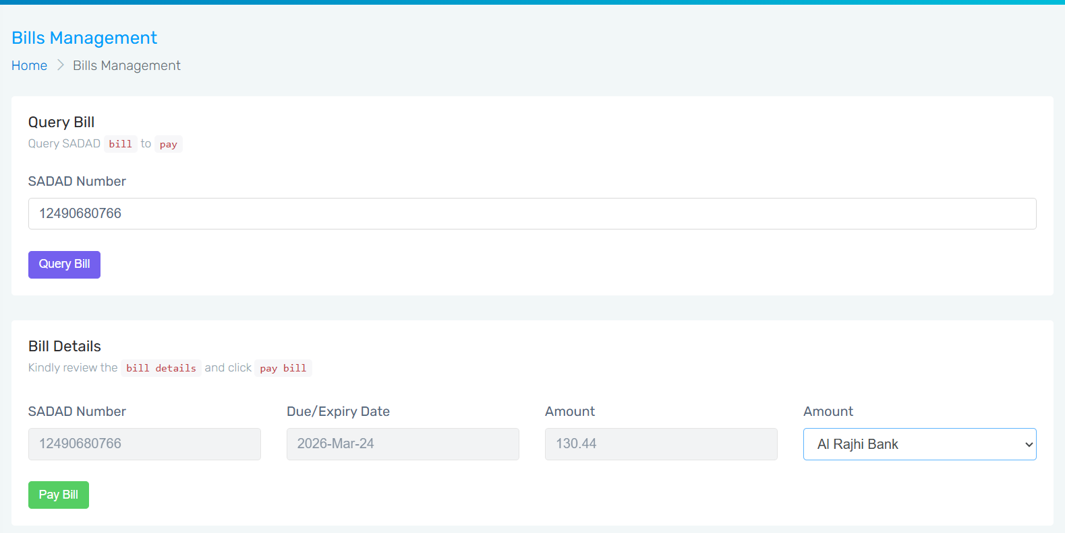
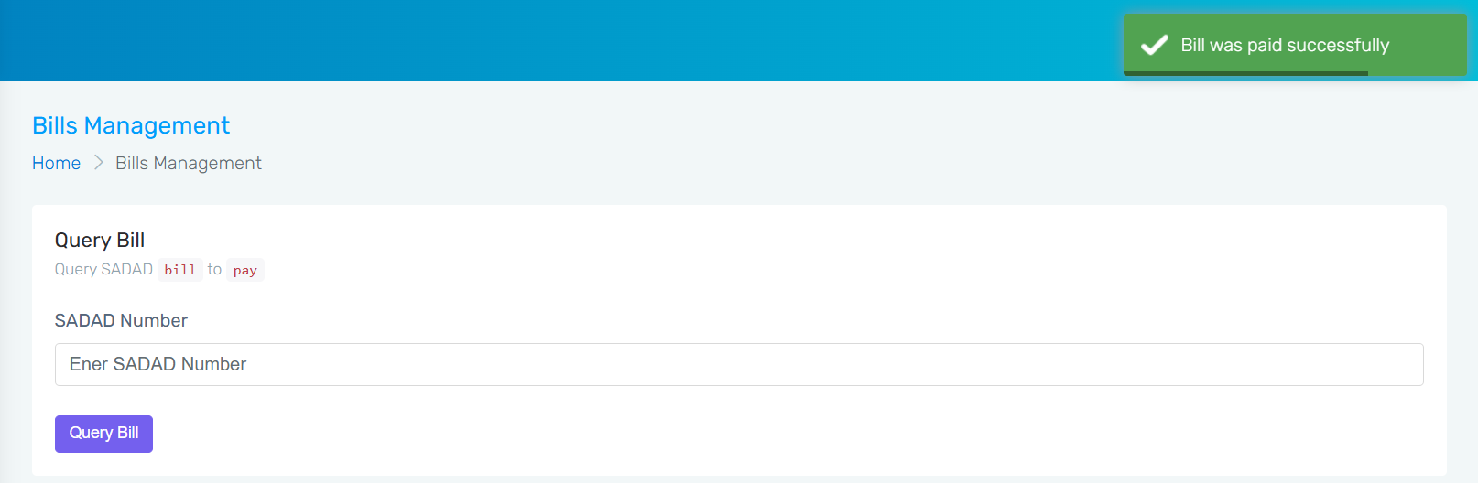
Bill paid through Rosom

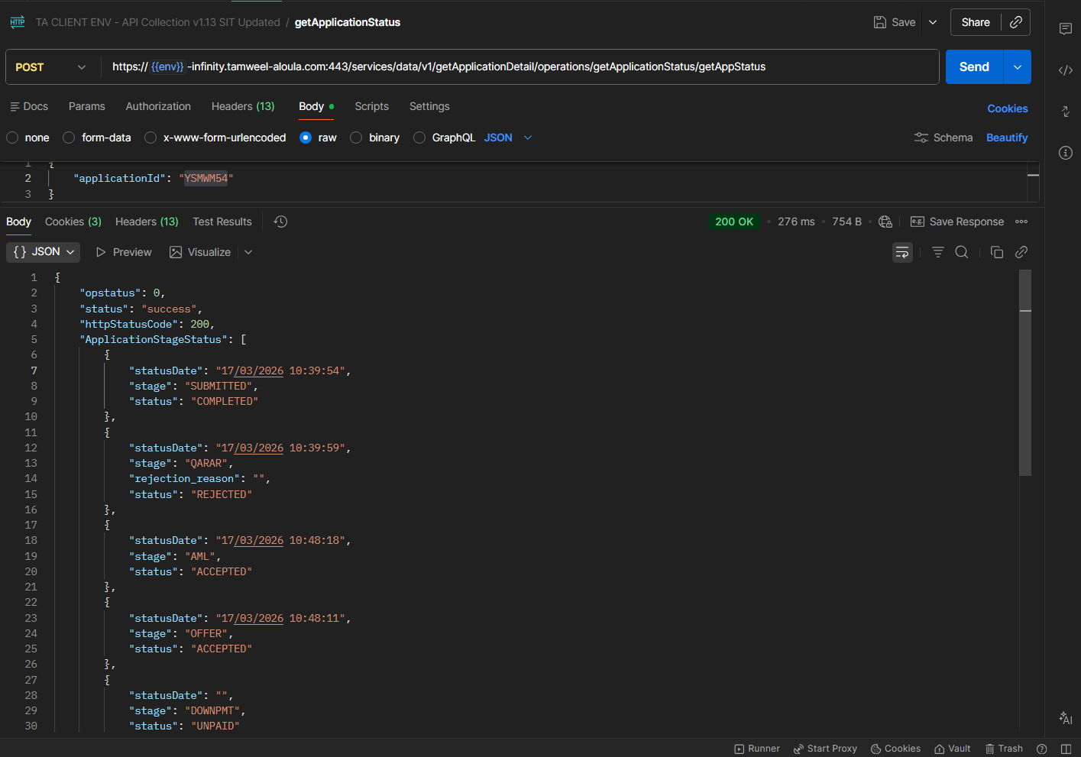
Status for both Offer and AML updated as Accepted

Contract
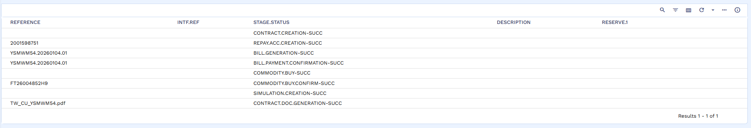
Contract Generated in transact

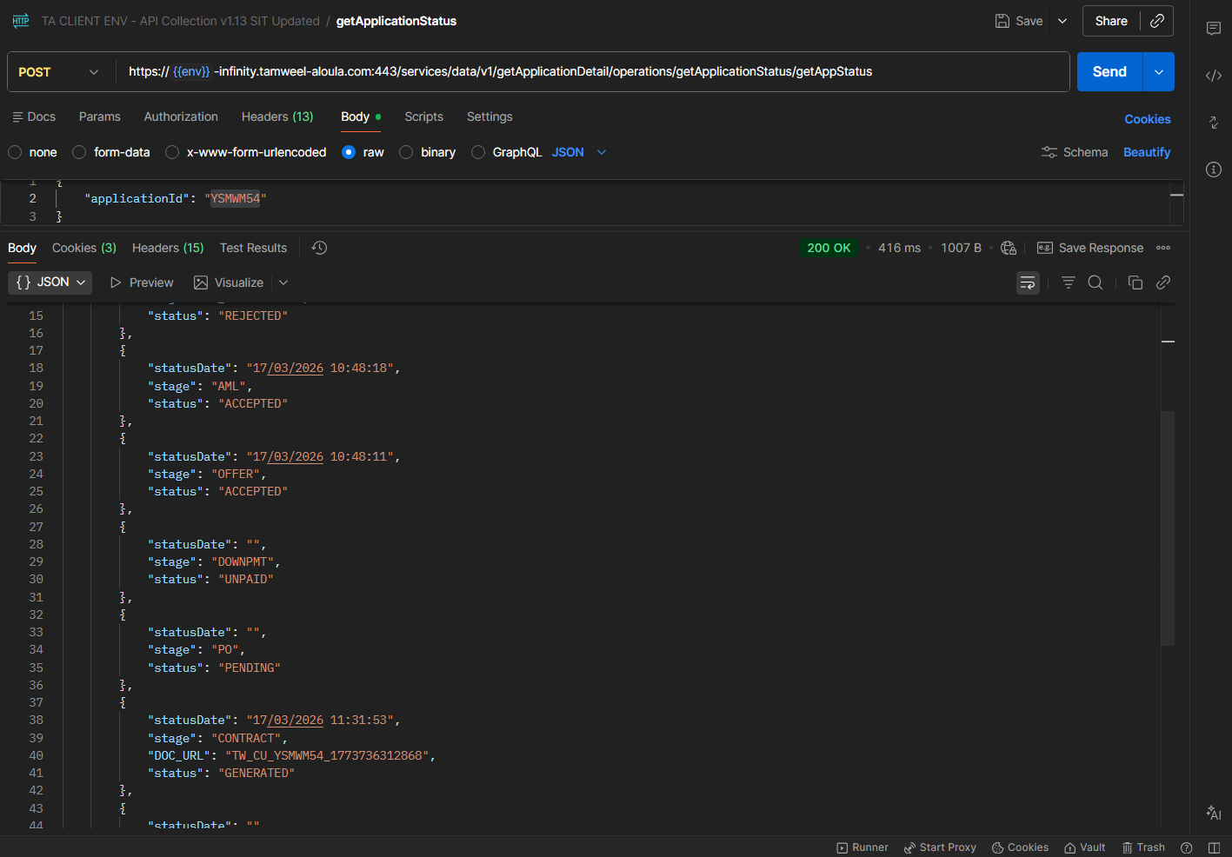
Contract reflected as Generated
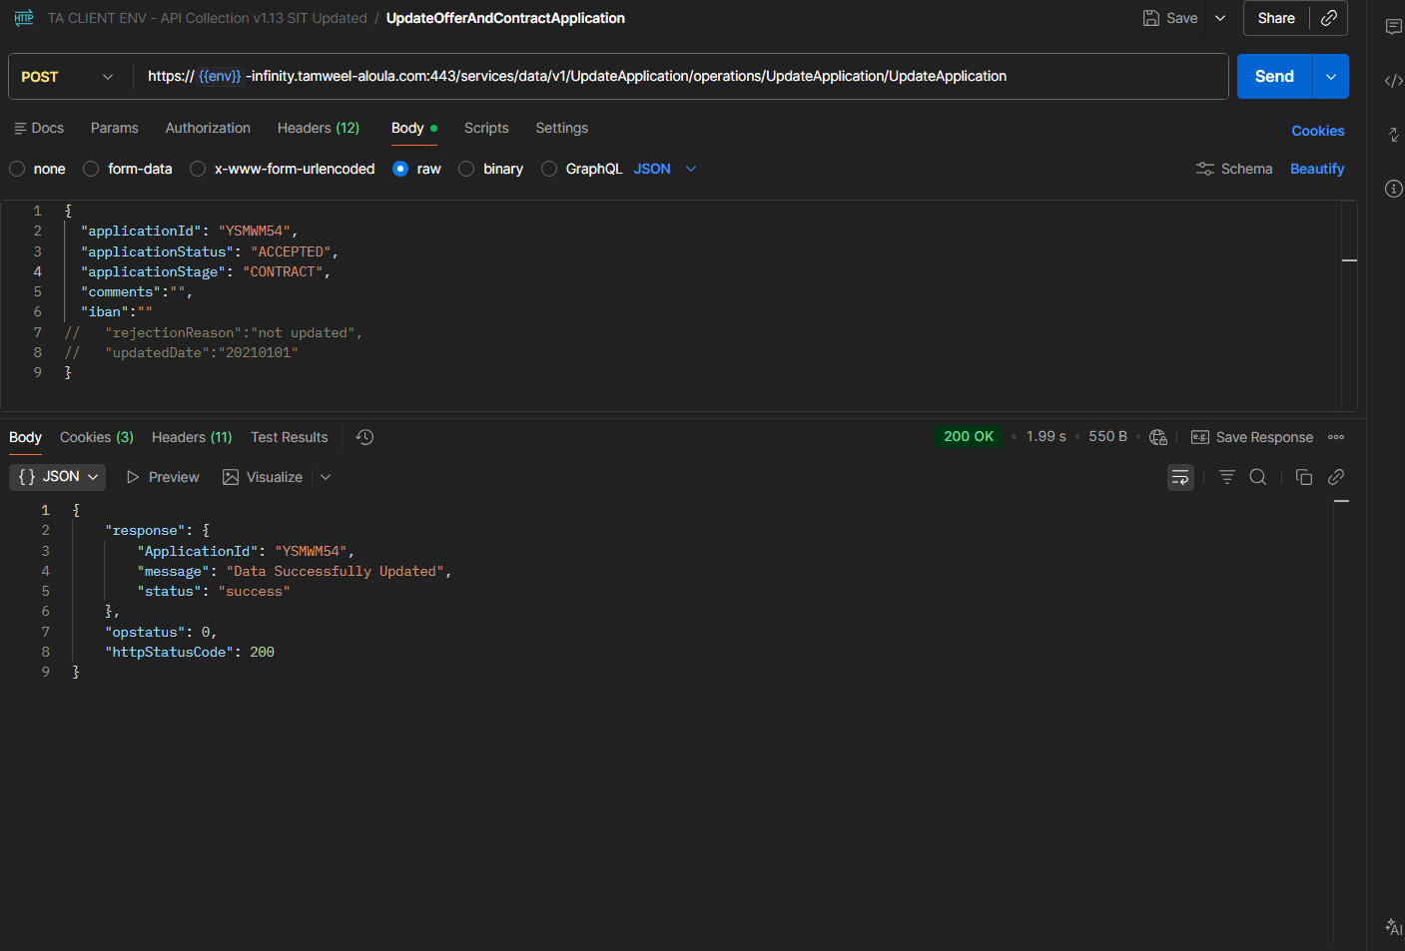
Contract accepted through API
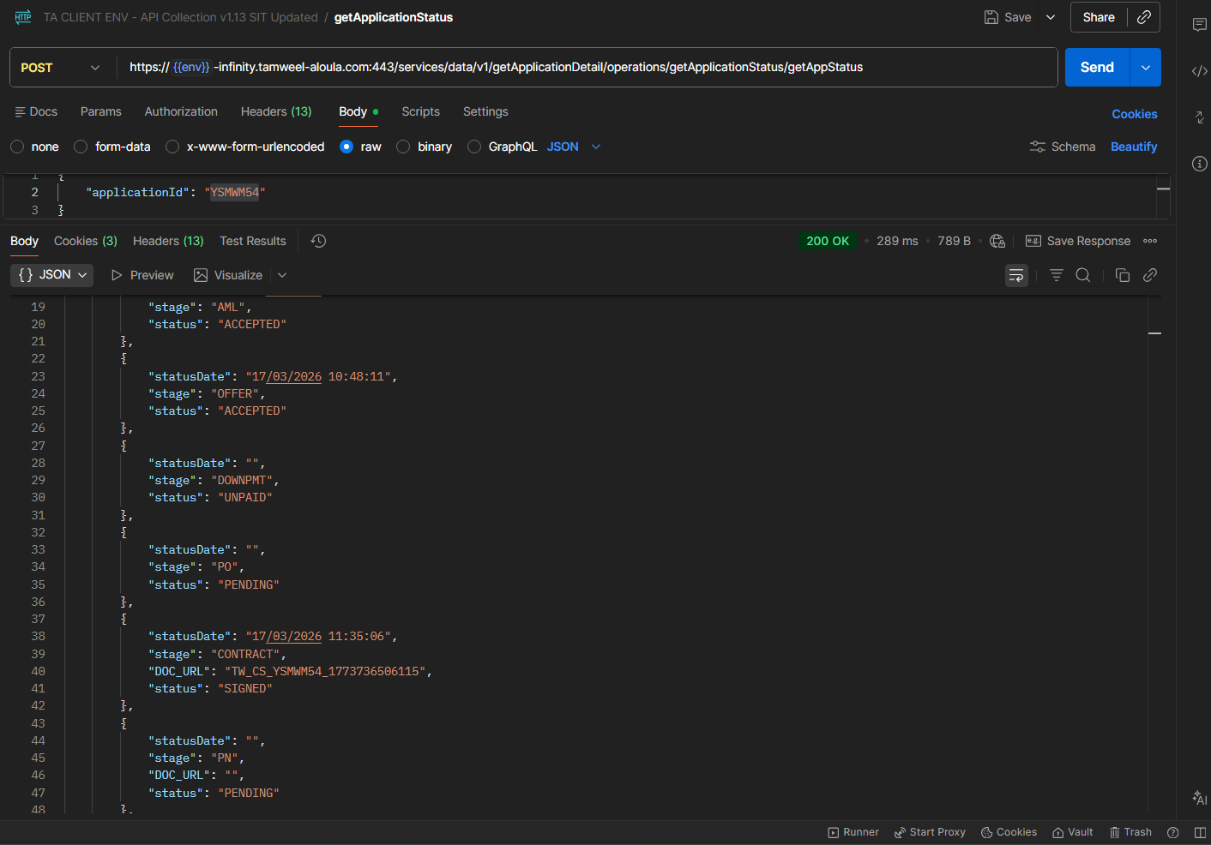
Contract status is updated as Signed

Promissory Note
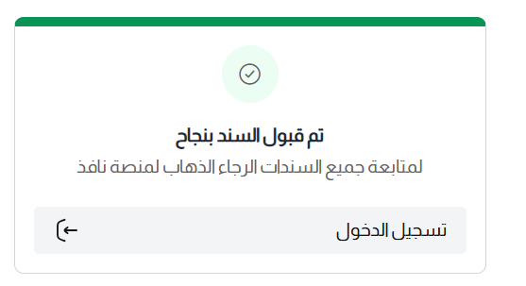
PN accepted
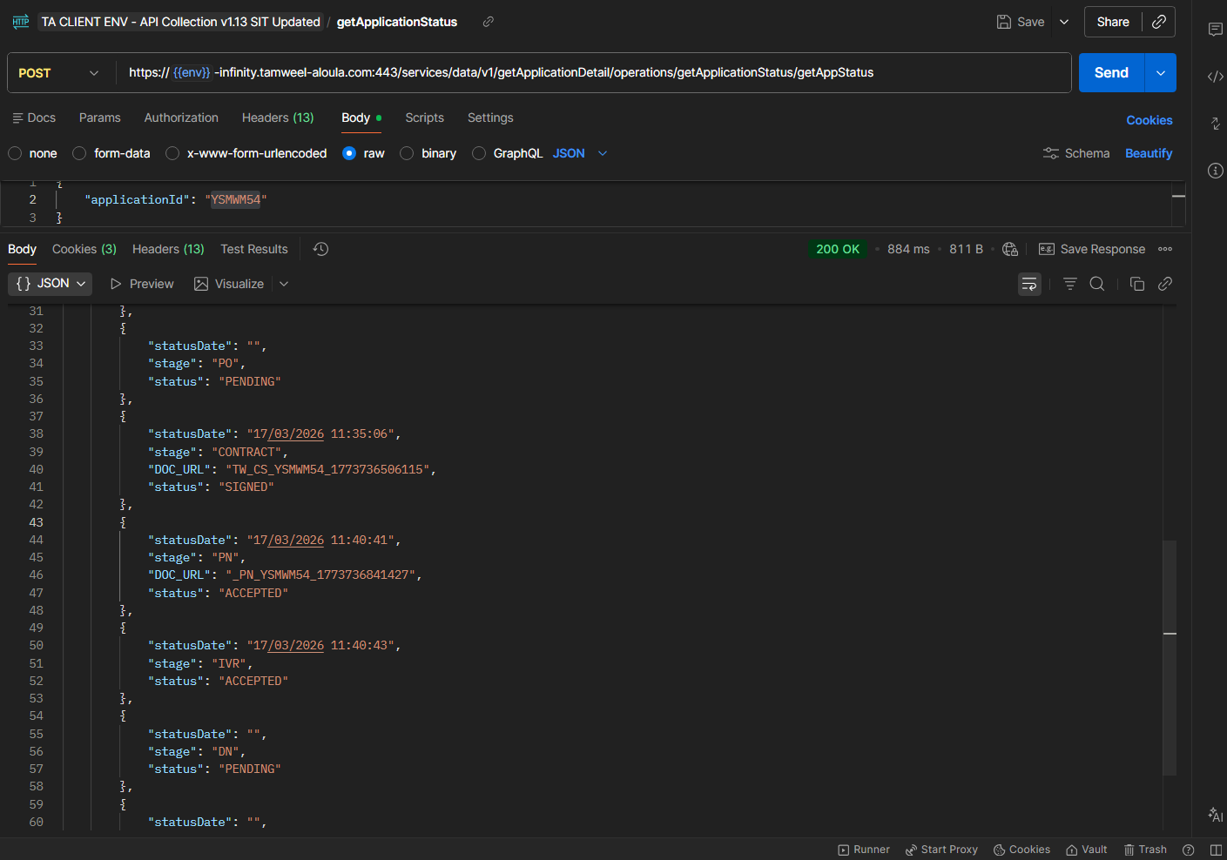
PN and IVR status is updated as Accepted

STP Complete
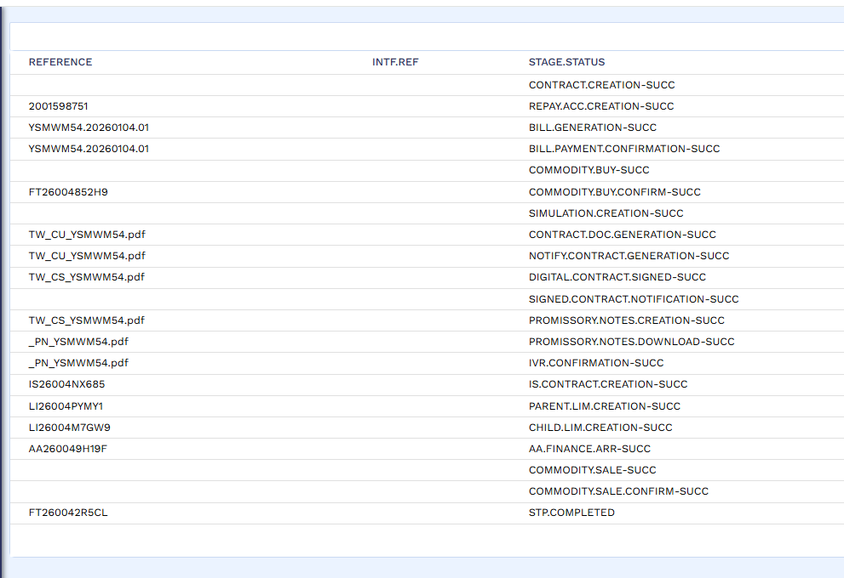
STP completed

New Arrangement
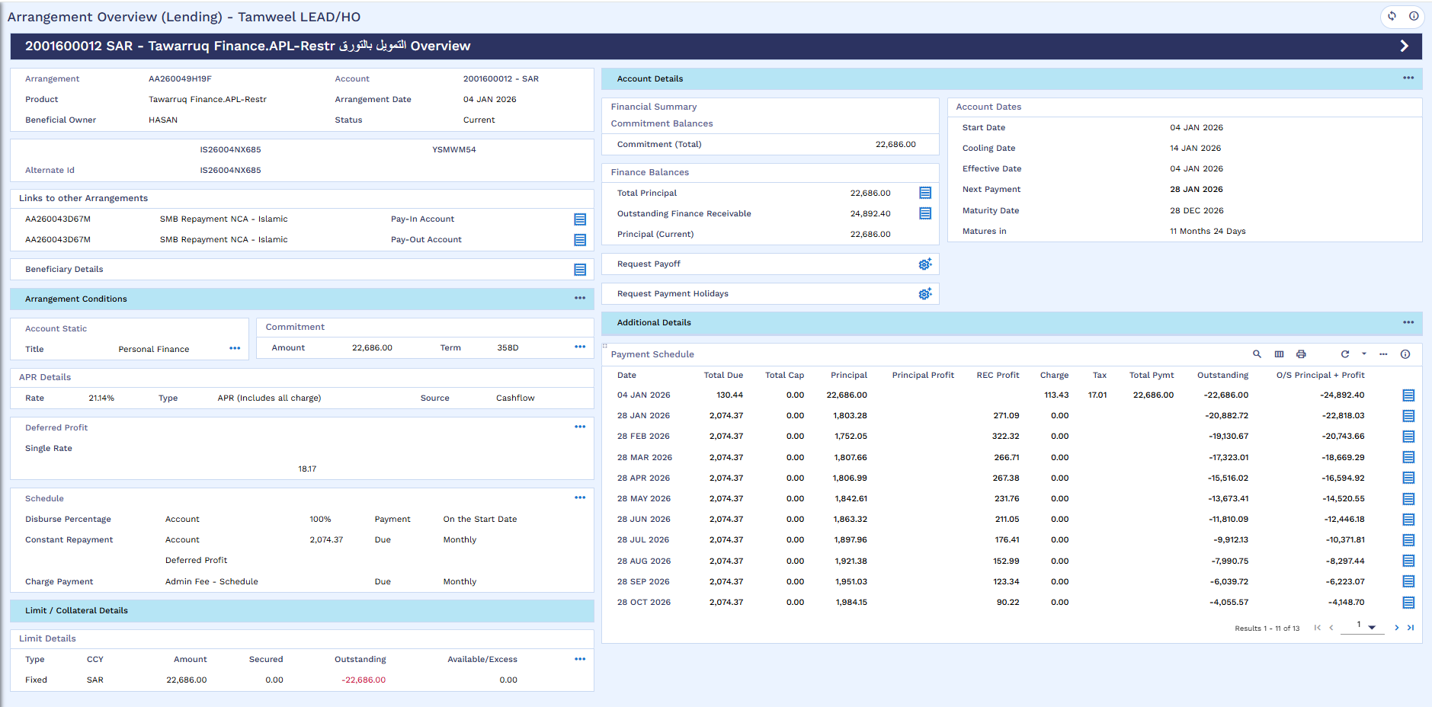
New/Restructure Arrangement Created

New Arrangement Accounting Entries
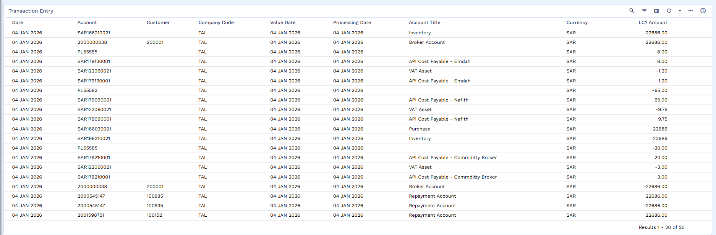
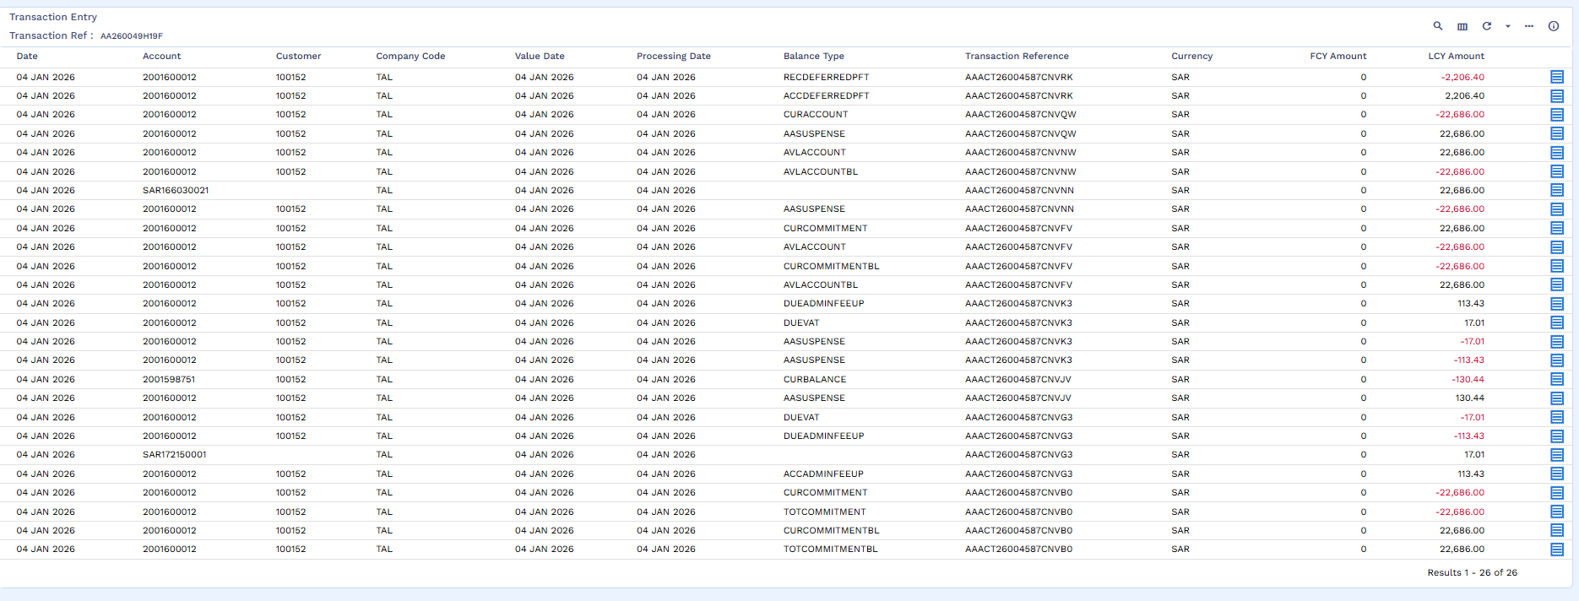
Accounting Entries
New Arrangement’s Repayment Account 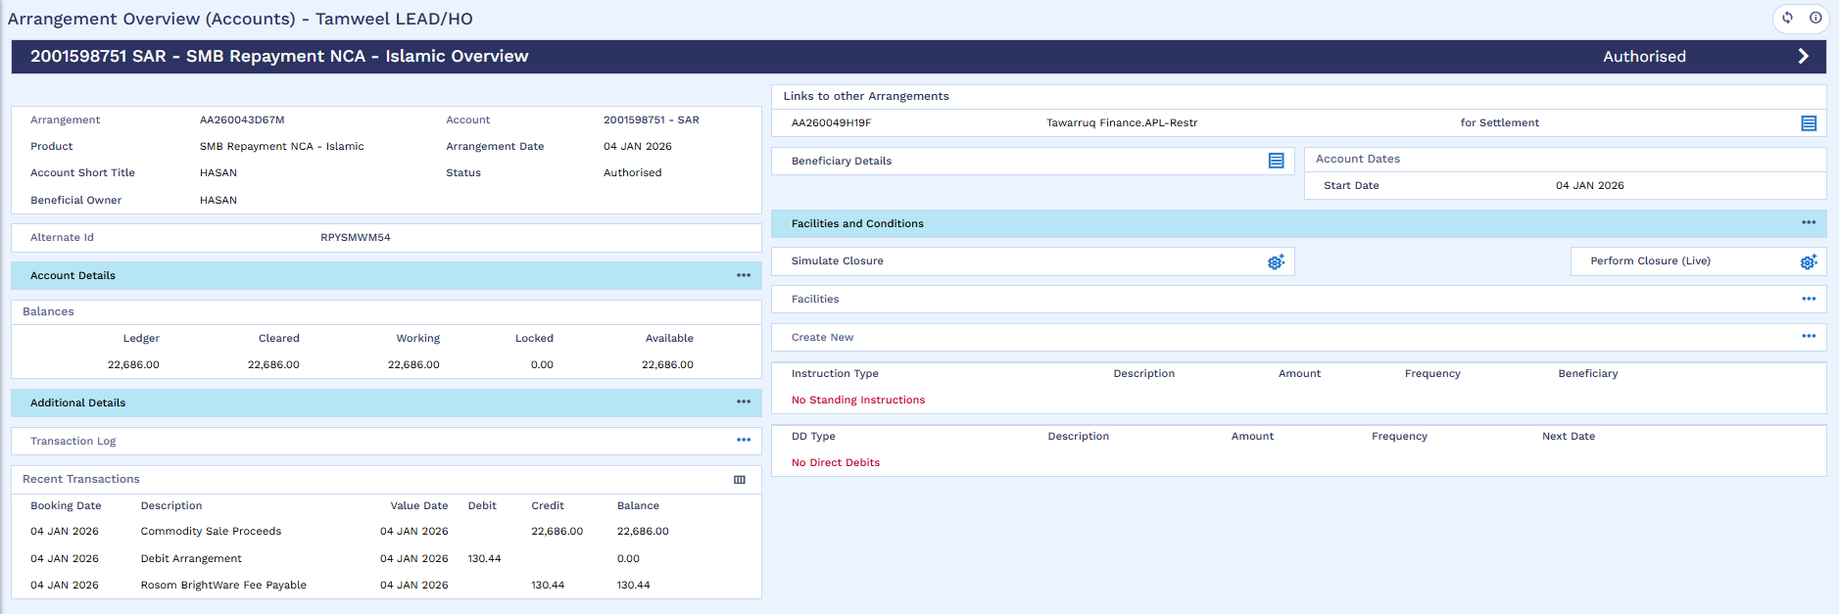
New / Restructured Arrangement Repayment account

Disbursement
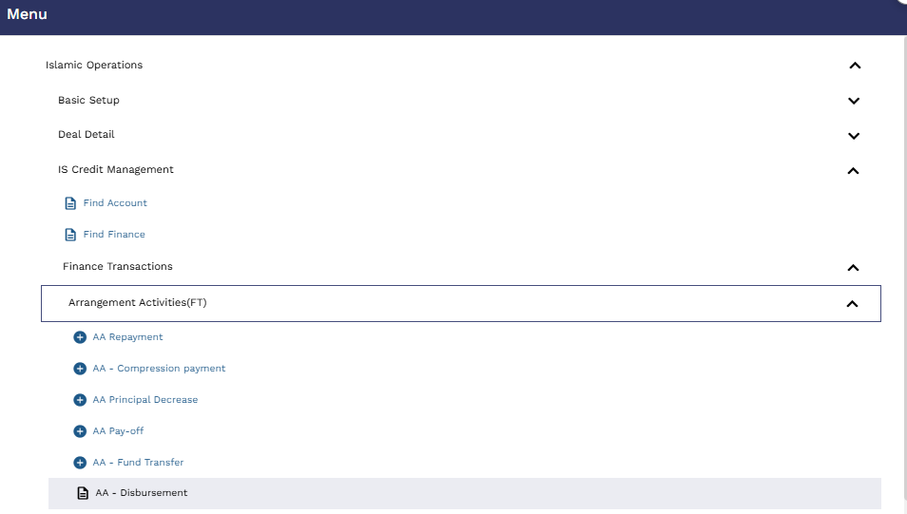
User will go to ?16 and click on AA Disbursement
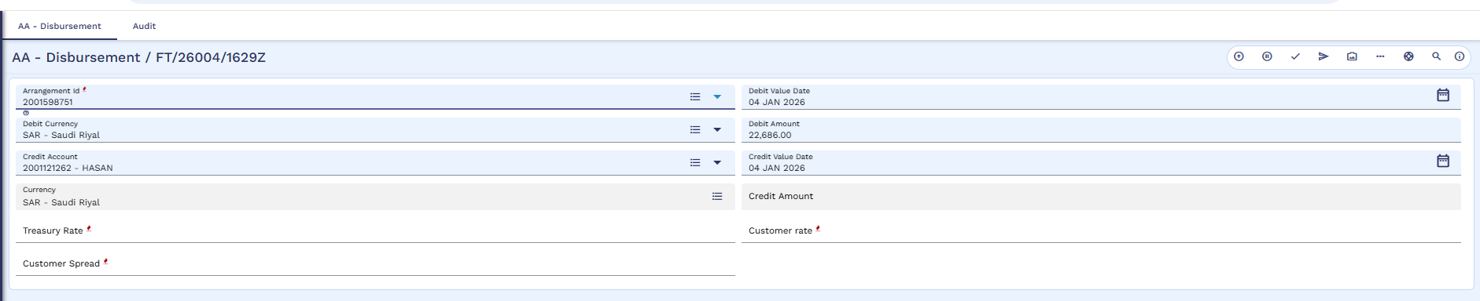
User will mention Debit account which is new arrangement repayment account and credit old arrangement repayment account in order to make the funds available to settle the old arranagment.
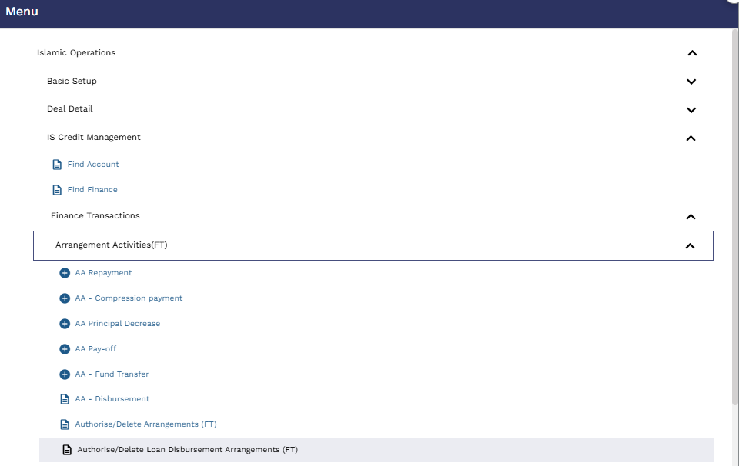
The Authorizer will go to ?16 and click on Authorise / Delete Loan Disbursement Arrangement (FT)
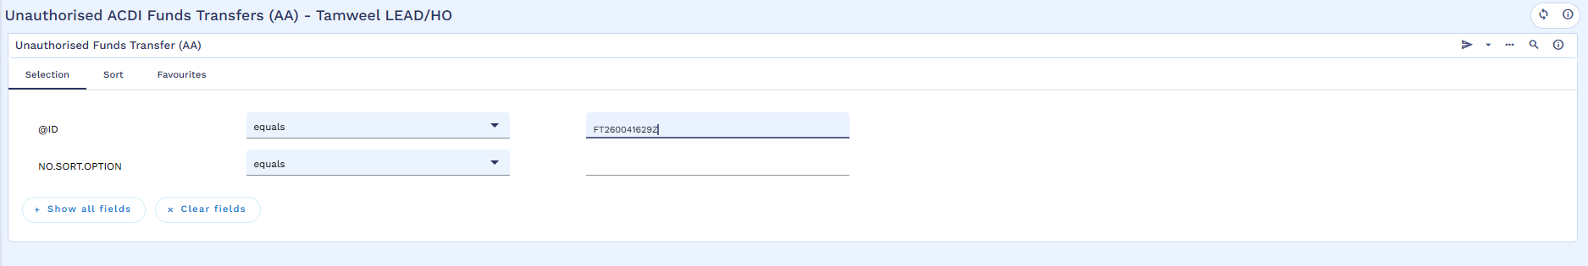
Authorizer will search the FT
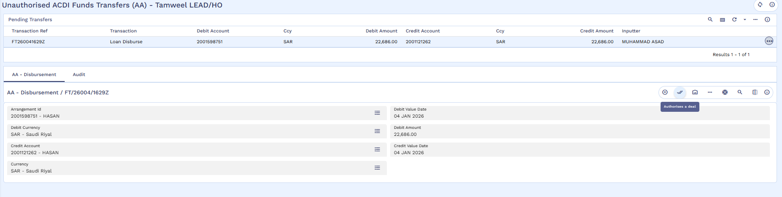
Authorizer will review
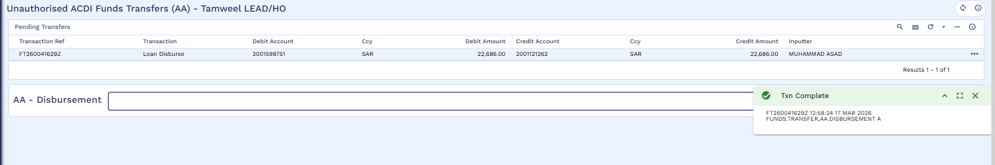
Commit the record.
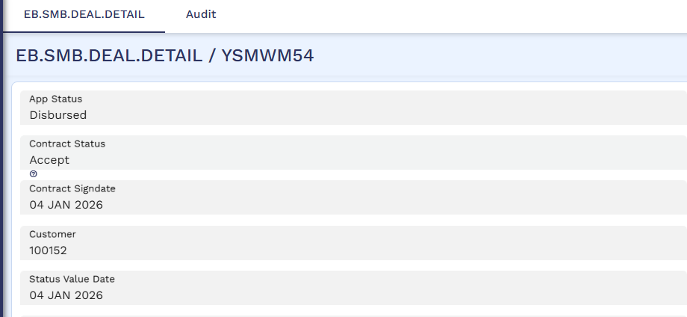
App status is changed to Disbursement.

Payoff of Old Arrangement
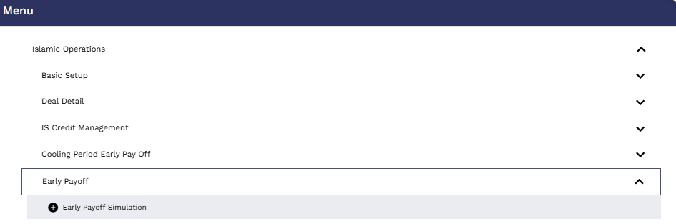
User will go to ?16 and perform early payoff simulation
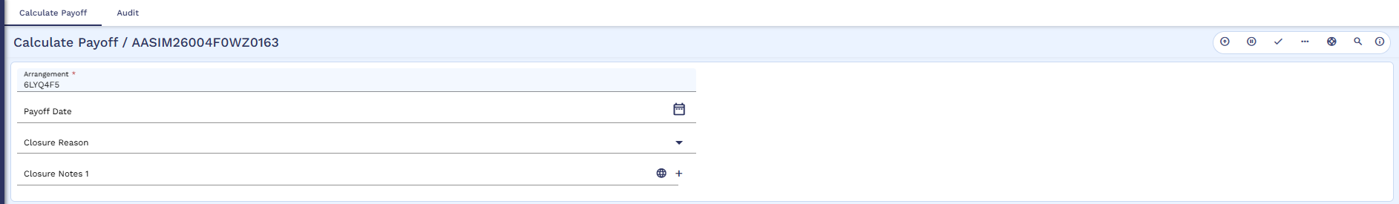
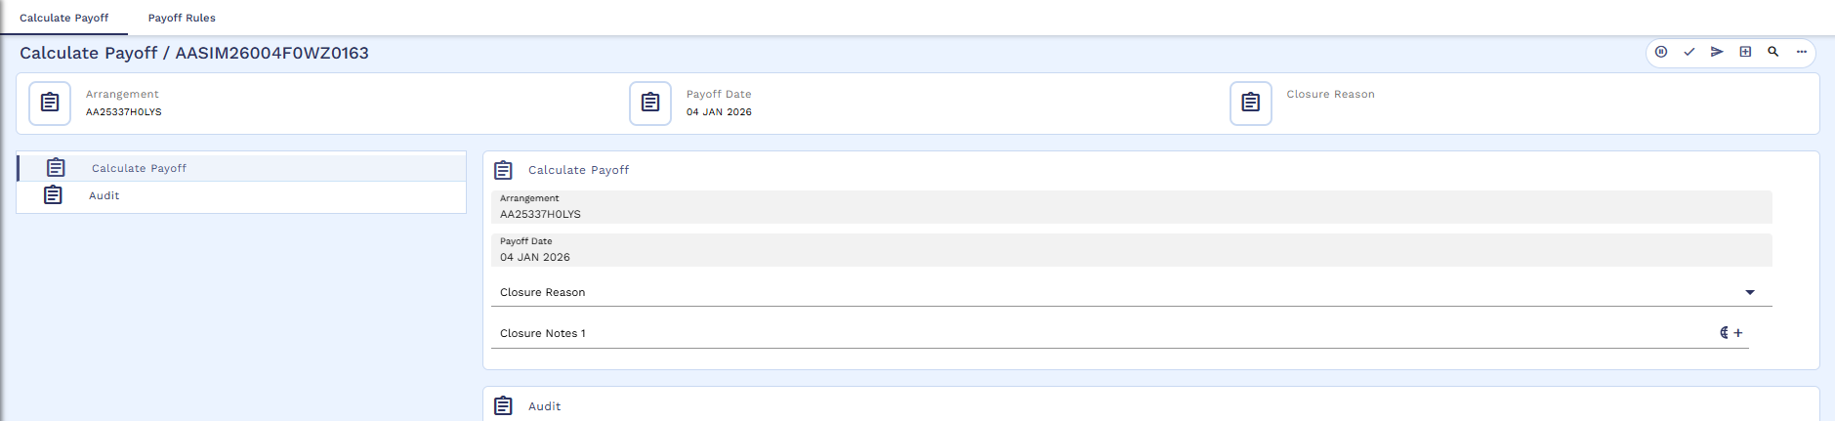
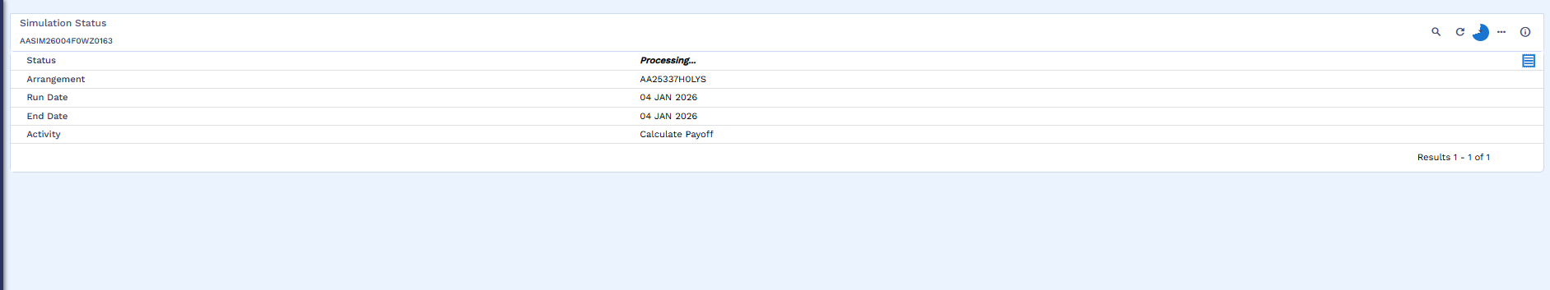
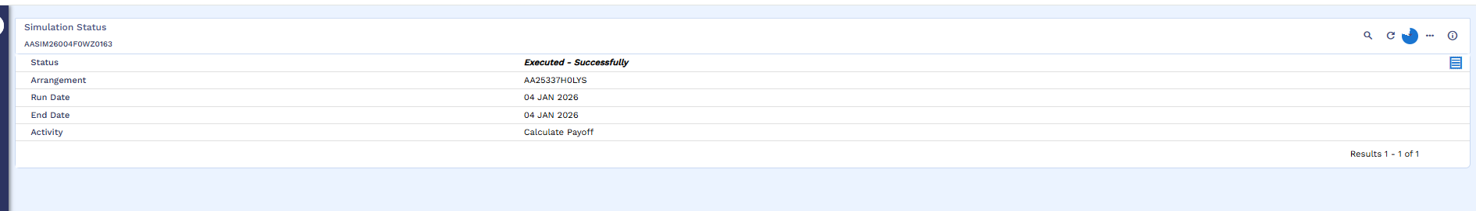
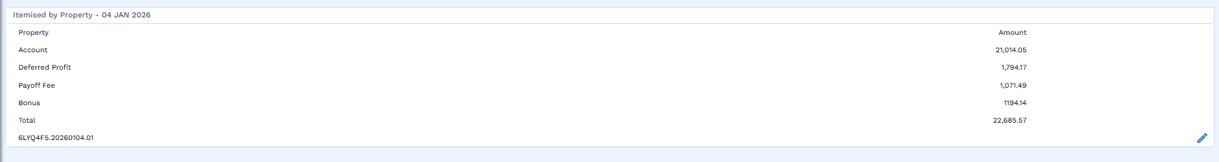
User will click on the edit icon to generate bill
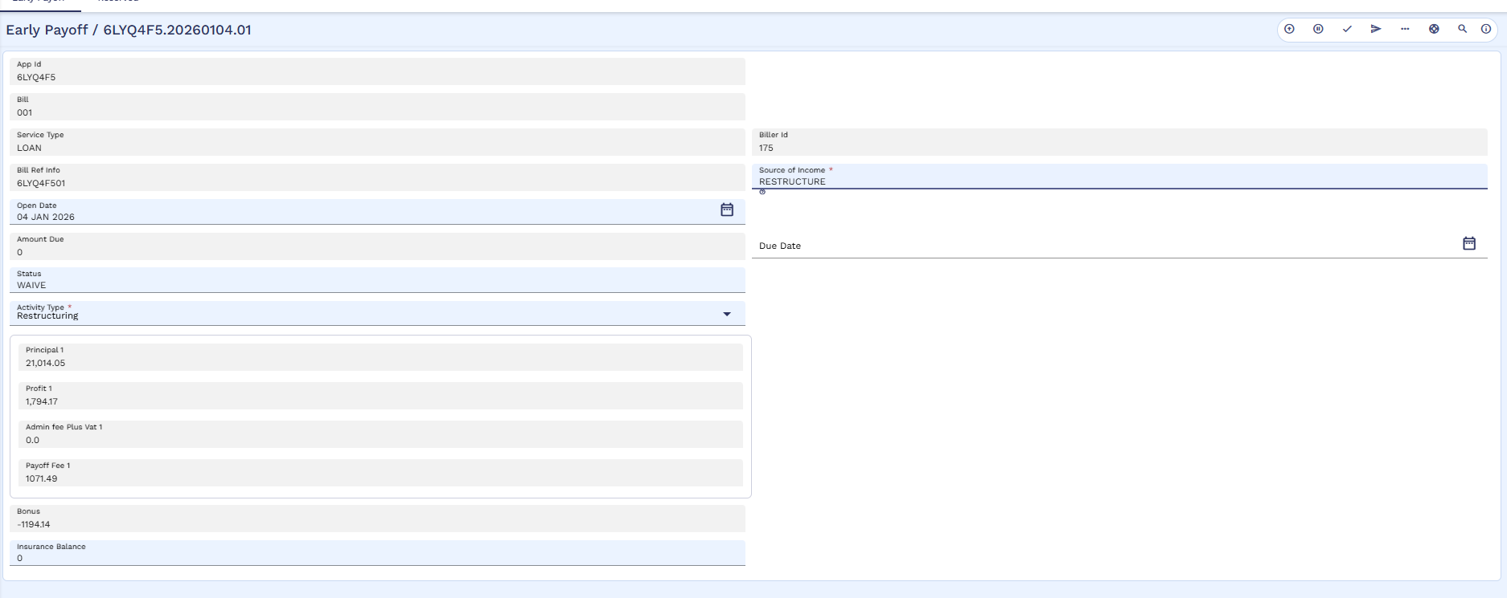
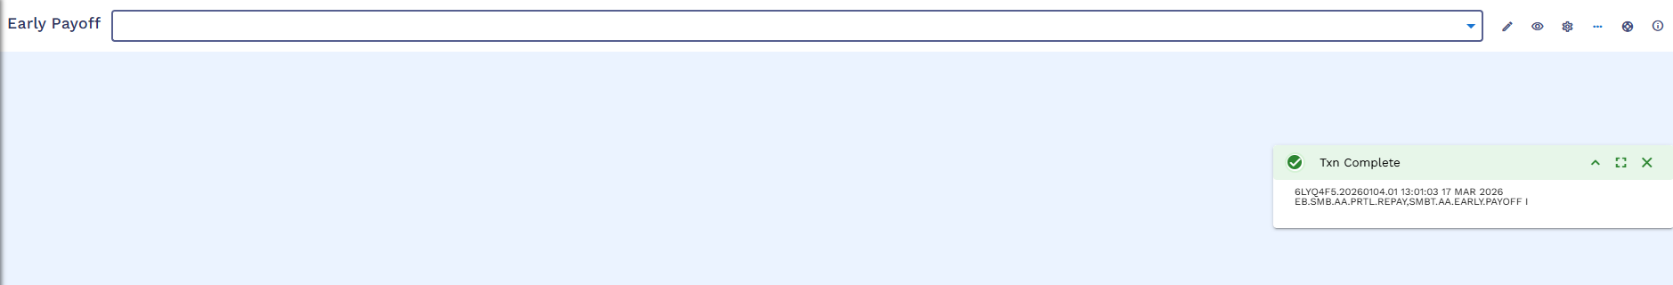
User will commit the bill
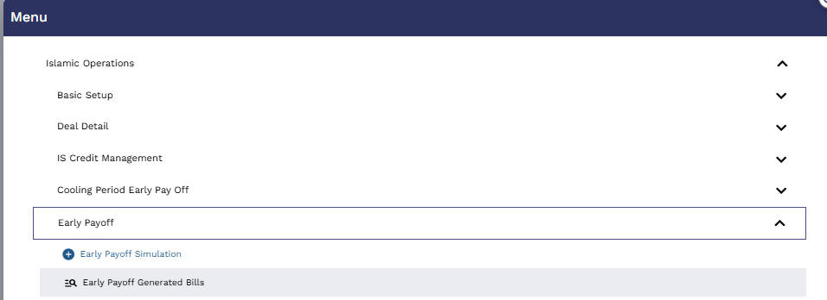
User will go to ?16 to see the Early Payoff Generated Bills
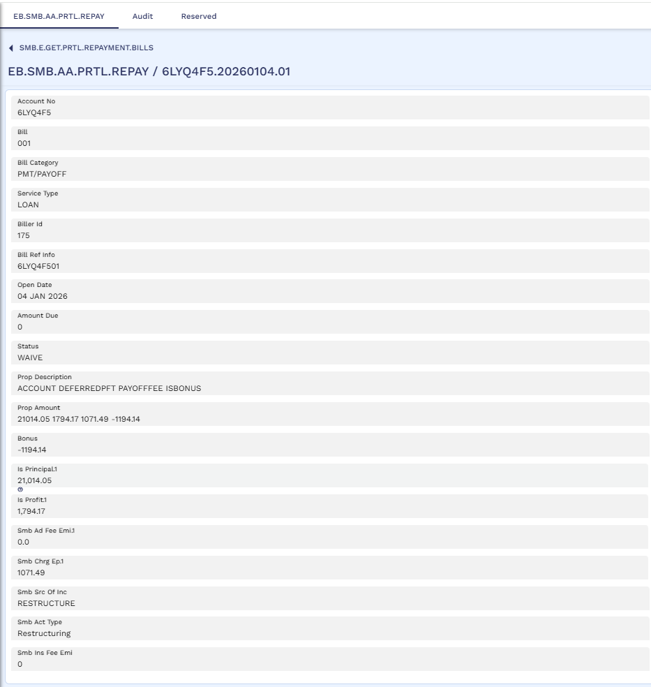
Bill generated in transact, Please note that there is no SADAD no as the repayment account contains the sufficient balance to settle the early payoff amount.
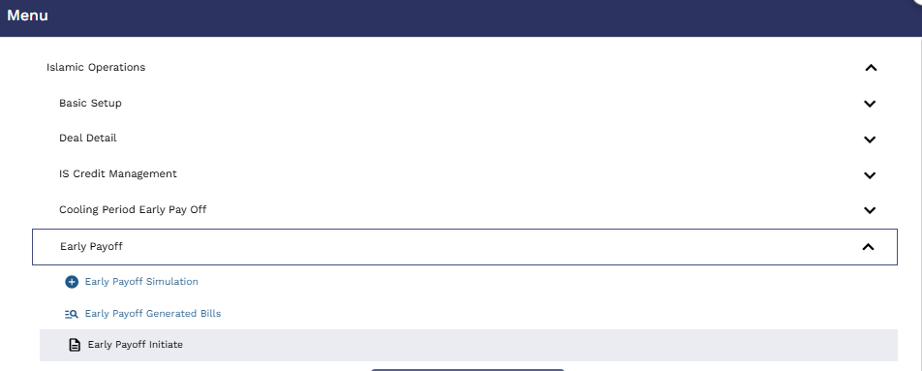
User will initiate the early payoff
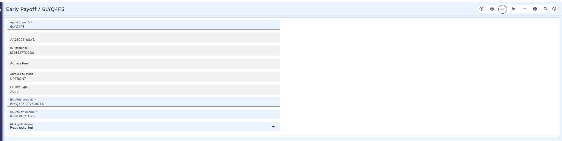
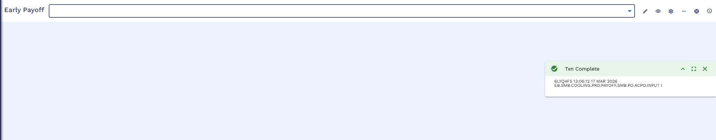
User will commit the early payoff initiate
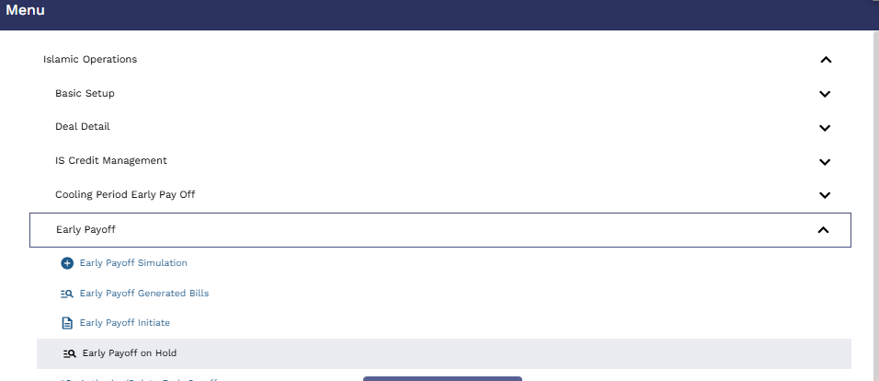
User will go to the early payoff on Hold
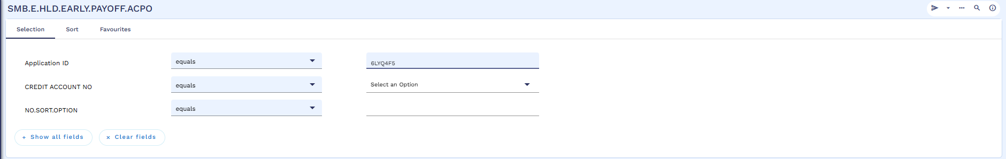
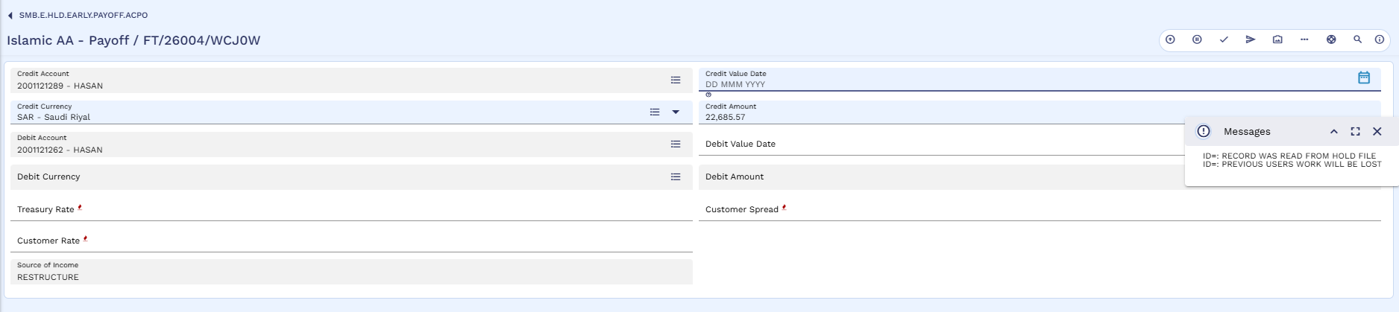
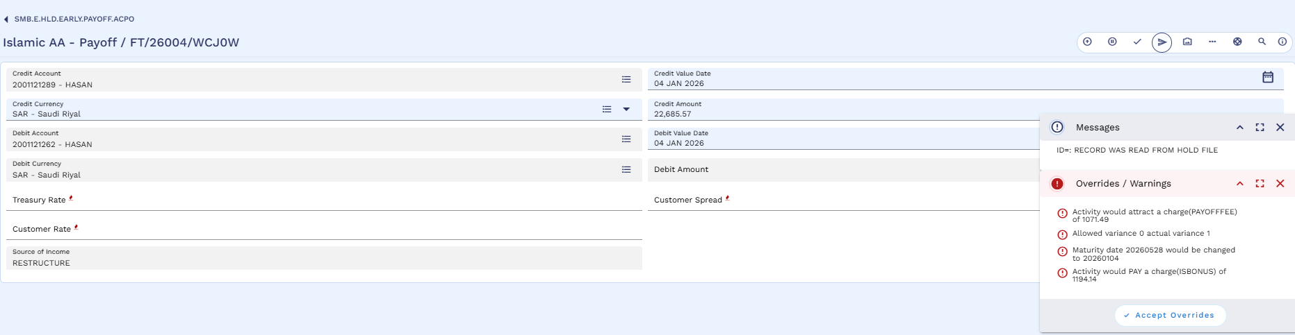
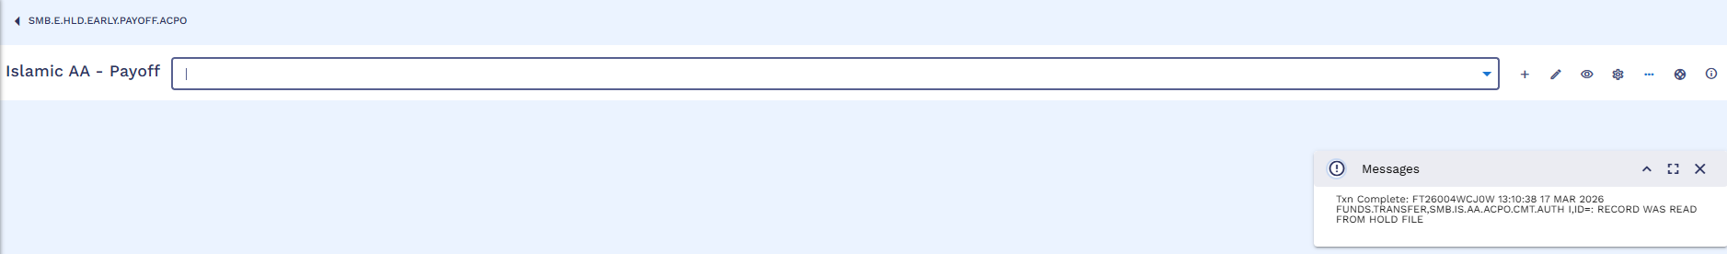
Commit the early payoff on Hold
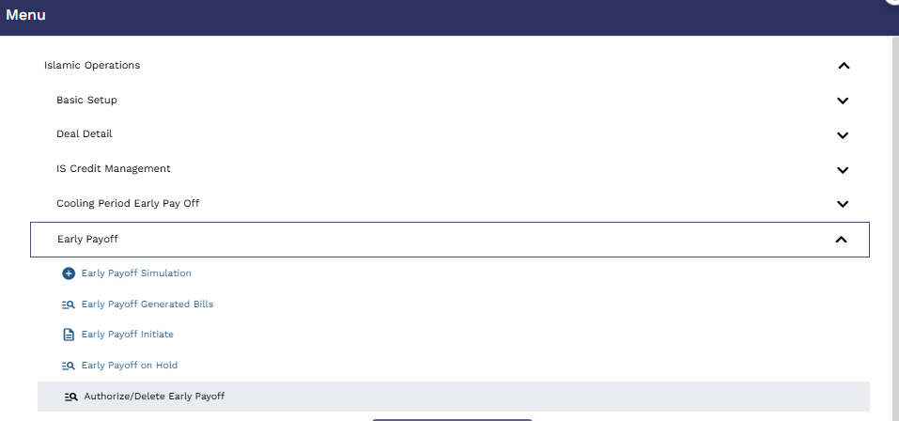
Authorizer will go to the ?16 to authorize the early payoff
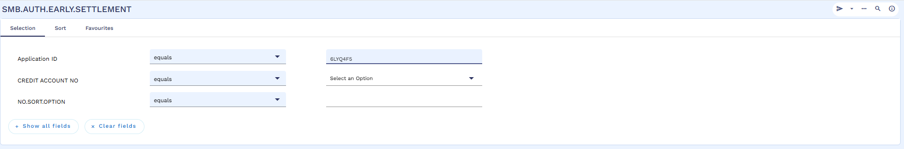
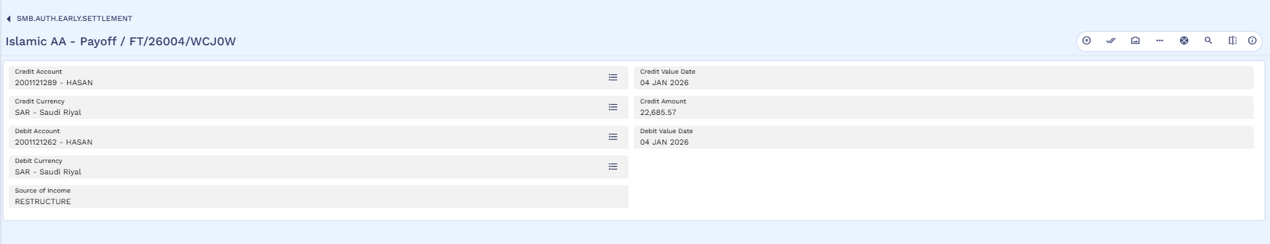
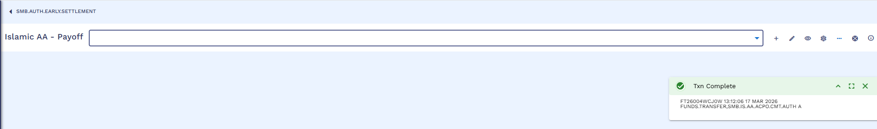
Authorizer will Authorize the payoff
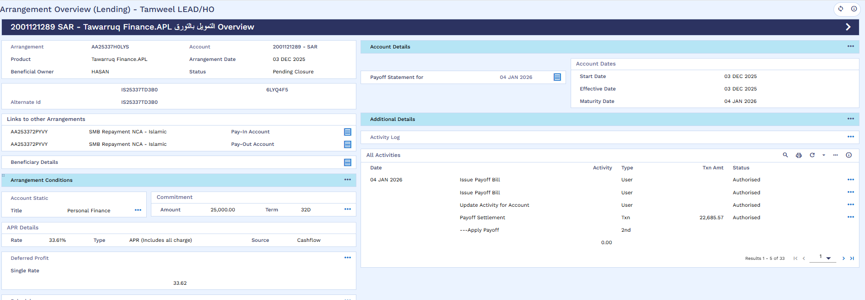
Old arrangement status changes to the “Pending Closure”
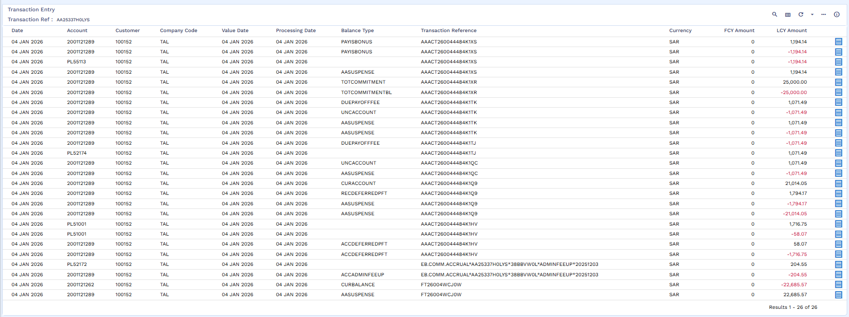
Payoff accounting entries

